Technology University of Durango
Information Technologies
Integrative Project I
BACHELOR’S DEGREE IN ENGINERING ON INFORMATION TECHNOLOGIES AND DIGITAL INNOVATION
“Software development to the psych-pedagogy department of Universidad Tecnológica de Durango”
Student:
- Barraza Torres Jesús Daniel
4°A BIS
Teacher:
- Raúl Iván Herrera González M.A.
September 2025

Gratitude
A great gratitude to my parents who gave me the tools and the will to continue; to my little brother who allowed me to discuss ideas for the making of this project; to my big brother who gave me the motivation tools to continue with the making of this project.

Abstract
The Universidad Tecnológica de Durango has several departments beyond those related to educational materials, which provide services to students with the goal of helping them perform optimally in both their studies and overall well-being, allowing them to continue their academic projects successfully.
One of these departments is the Psych-pedagogy Department, which is responsible for maintaining students’ emotional well-being—particularly for those who have been reported for socio-emotional issues—with the purpose of ensuring their integrity in cooperation, teamwork, and other extracurricular activities organized by the institution.
However, the Psych-pedagogy Department experiences time inefficiencies due to the need to manually record and organize appointments and related notes, which significantly slows down their processes.
The goal of this project is to reduce this registration time by developing software that can be used by the department’s staff to streamline their operations and maintain optimal performance.

Resumen
La Universidad Tecnológica de Durango posee varios departamentos más allá de los de material educativo los cuales cumplen con la función de otorgar servicios a los estudiantes con el objetivo de que puedan rendir de manera óptima sus servicios tanto de estudio como de bienestar general para continuar con sus proyectos.
Uno de estos departamentos es el departamento de psicopedagogía, los cuales se encargan de mantener el bienestar emocional del estudiante (generalmente aplicado a los estudiantes los cuales han sido reportados por problemas a nivel socioemocional) con el fin de mantener la integridad del estudiante ante la cooperación, el trabajo y otras actividades extraescolares que emite la institución.
Sin embargo, el departamento de psicopedagogía posee una falla de tiempo al tener que estar registrando y diagramando las citas y notas de las mismas de manera manual, alentando mucho sus procesos.
El objetivo del proyecto es el de reducir este tiempo de registro utilizando un programa de software que pueda ser utilizado por los trabajadores de dicho departamento y así agilizar sus procesos para mantener un rendimiento ideal.

Changelog
Version | Date | Responsible | Included changes
0.0.1 | 6/10/25 | Barraza. J | The cover, header, footer, and formatting were added.
0.0.2 | 6/10/25 | Barraza. J | Gratitude and the abstract were added
0.0.3 | 6/10/25 | Barraza. J | The table of contents was added.
0.0.4 | 7/10/25 | Barraza. J | The introduction was completed.
0.1.1 | 7/10/25 | Barraza. J | Two subsections of the executive summary were created, covering the problem description and objectives.
0.1.2 | 7/10/25 | Barraza. J | Two subsections of the executive summary were created, covering the deliverables and techniques used.
0.2.1 | 7/10/25 | Barraza. J | The context diagnosis was drafted.
0.2.2 | 7/10/25 | Barraza. J | Both the problem-need definition and the stakeholder map were started, along with the problem tree diagram.
0.2.3 | 7/10/25 | Barraza. J | A brainstorming session and the preliminary CANVAS were carried out.
0.2.4 | 7/10/25 | Barraza. J | Section 2 was completed with the SMART goals and the project datasheet.
0.2.5 | 7/10/25 | Barraza. J | The document formatting was updated in parallel.
0.2.6 | 9/10/25 | Barraza. J | The document was corrected according to the observations.
0.2.7 | 10/10/25 | Barraza. J | An English version was generated in parallel.
0.3.1 | 31/10/25 | Barraza. J | Chapter 3 was initialized
0.3.2 | 3/11/25 | Barraza. J | Roadmap and WBS diagrams were added on chapter 3.
0.3.3 | 4/11/25 | Barraza. J | Chapter 3 was finalized
0.3.4 | 5/11/25 | Barraza. J | Chapter 3 was created on the English version
0.4.1 | 23/11/25 | Barraza. J | Start of chapter 4
0.4.2 | 5/12/25 | Barraza. J | End of chapter 4
0.5.1 | 5/12/25 | Barraza. J | Almost all of the chapter 5
0.6.1 | 6/12/25 | Barraza. J | All of the chapter 6
0.7.1 | 6/12/26 | Barraza. J | All of the chapter 7
0.8.1 | 6/12/25 | Barraza. J | All of the chapter 8
0.9.1 | 6/12/25 | Barraza. J | All of the chapter 9
1.0.1 | 6/12/26 | Barraza. J | The end of the Spanish document
1.0.2 | 7/12/25 | Barraza. J | The end of the English document

Table of content
Gratitude 1
Abstract 2
Resumen 2
Changelog 4
Introduction 9
Executive summary 10
Problem’s description 10
General objectives and expected key results 10
Summarized reaches and main deliveries 10
Used techniques 11
Environment analysis and conceptualization 12
Context analysis 12
Need and Demand for Psychological Services Among Students 12
Budget Constraints in Higher Education (Context: Mexico) 12
Maturity and Evidence for Automated Scheduling Solutions 12
Integration with the University Ecosystem 12
Problem – Necessity definition 13
Interested map 13
Cause-Effect Analysis 14
Idealization and creative ideas 14
SMART objectives and success criteria 16
Project’s profile 17
Project planification 18
Project requirements 18
Prioritized list 18
Functional and non-functional requirements 19
Acceptation criteria 19
Roadmap and initial strategy 20
Work Breakdown Structure (WBS) 21
Chronogram 22
Resources and budget 23
KANBAN board and Done Definition (DoD) 23
RACI matrix and risks 24
Design, development and proof 26
Architecture and Solution Design 26
Architecture Design 26
Chosen Technologies 27
Justifications 28
Functional Modeling 28
Use Cases 28
Wireframes / UI 30
Usability Guidelines 31
Coding Standards and Repository 32
Code Conventions 32
GitFlow Branching 33
Commit Messages 33
Code Documentation 34
Incremental Implementation 34
Splint logs 34
Test Plan 37
Strategy 37
Test Cases 37
Tools 37
Test Results and Performance Indicators 38
Reports 38
Bugs 38
Coverage 38
Performance Metrics 38
Reliability 39
Adaptation, validation and divulgation 40
Changes gesture and improvements 40
Changes request 40
Impact analysis 40
Socioemotional management and ethics 42
Leadership and collaboration 42
Sustainability and social responsibility 42
Ethical frame and security. 42
Evidences portfolio 43
Own’s checklist 43
Conclusions and future work 45
Achievements vs objectives 45
Limitations and next steps 45
References and normatives 46
Template matrices 48
Matrices and templates 48
Design artifacts 74
Process evidence 77

Introduction
At the Universidad Tecnológica de Durango, psychology departments were implemented within the university with the objective of “Providing care to students who experience difficulties in their academic, personal, family, and social activities that affect their academic development. Likewise, offering academic guidance with a human development approach, assisting students in building their personal and professional identity, emphasizing the personal-social, academic, and family areas.” (Universidad Tecnológica de Durango, n.d.).
This is particularly important for the individual in question, since it allows one to face problems that arise by using their emotional skills. As experts from the website La Depresión state: “Mental health is a state of emotional and mental well-being in which an individual is able to cope with stressful situations in life, display and develop their skills, and also be capable of learning, contributing to society, and working properly.” (La Depresión, n.d.).
Due to the great importance of mental health care, one can assume that it is essential for mental health support to be provided as quickly as possible — that is, it should reach those who need it without interruptions or delays. However, at the Universidad Tecnológica de Durango, there is a small issue.
The responsiveness of the psychology department depends on whether appointments are properly organized and recorded for later documentation, which can lead to more serious problems in certain cases.
The objective of our study is to determine whether the response time of psychological support for a person actually affects the outcomes of that support. In turn, this justifies a project aimed at providing faster psych-pedagogical assistance.
This study can be used to improve psych-pedagogical services elsewhere, as well as for future research related to mental health and project resolution.
The following sections describe the methods, results, and discussion of the psych-pedagogical program to be implemented.

Executive summary

Problem’s description
The Technology University of Durango has certain problems regarding the organization between their diverse departments because those are very wide, that’s why this project is developing.
The objective of this project is to speed up, via a desktop program, the appointments register of the psycho-pedagogy department from the university previously mentioned, with the objective to provide a better care to the students of the place mentioned before.

General objectives and expected key results
KR | Metric (how it’s measured) | Baseline (if applicable) | Goal (target) | Due date / Responsible
KR1: Improvement in response times of the psycho-pedagogy department | Average time to assign an appointment | 3 business days on average | ≤ 1 business day on average | 2026-02-15 / Name
KR2: Improvement in the academic performance of students served | Average grades before and after counseling | Average of the previous semester | ≥ 10% increase in academic average | 2026-10-01 / Name
KR3: Improvement in appointment care and follow-up | Student satisfaction level (survey) | 70% satisfaction | ≥ 90% satisfaction in subsequent surveys | 2026-02-15 / Name

Summarized reaches and main deliveries
The reach of this project goes directly to the Technological University of Durango’s psych-pedagogy department, with the delivery of:
- Demo – Deliverable on the second unit (2 months)
- Full diagrams - Deliverable on the second unit
- Desktop app - Deliverable on the third unit (3 months)
- User guide - Deliverable on the third unit
- Developer guide - Deliverable on the third unit

Used techniques
For this project it was used:
- Problem’s tree diagram
- Brainstorm
- CANVAS model
- KANBAN table

Environment analysis and conceptualization

Context analysis

Need and Demand for Psychological Services Among Students
Recent studies show that mental health issues among university students are common and remain a key operational priority for institutions. Reports such as the Healthy Minds Study indicate high rates of anxiety, depression, and use of mental health services within the student population, resulting in sustained demand for counseling and support programs. This justifies the implementation of systems that facilitate access and ongoing monitoring.

Budget Constraints in Higher Education (Context: Mexico)
Per-student funding in Mexico is generally lower than in many OECD countries. OECD reports highlight relative budgetary constraints in spending per student, which affects the ability to expand in-person services and necessitates cost-effective and scalable technological solutions. This favors SaaS options or open-source/self-hosted solutions with low maintenance costs.

Maturity and Evidence for Automated Scheduling Solutions
Both literature and practice show that self-scheduling and automated reminders reduce no-shows, improve punctuality, and decrease administrative burden. Clinical evidence supports their safety and usefulness, provided they include privacy safeguards and clinical priority controls.

Integration with the University Ecosystem
The software should consider interoperability with student information systems (SIS), single sign-on (SSO/LDAP), academic calendars, and (if applicable) internal health records. In Mexico, digital transformation experiences in universities highlight the need to adapt solutions to heterogeneous infrastructures (e.g., variable connectivity and different levels of digitalization).

Problem – Necessity definition
With all the above, one could see why psycho-pedagogy is important inside the university institutions, however, the question still remains, ¿What is the context of the situation? Next, it will be presented.
The psychology is so important on university areas. “University students ”

Interested map
In this project certain actors have certain interests on whatever they can do in this project:
- Workers of the psycho-pedagogy department: They have the interest on this project to be the best organized possible.
- Institution directives: They have the interest on this project to be efficient, fast and low-resource consumption.
(Incomplete due to data not reached)

Cause-Effect Analysis
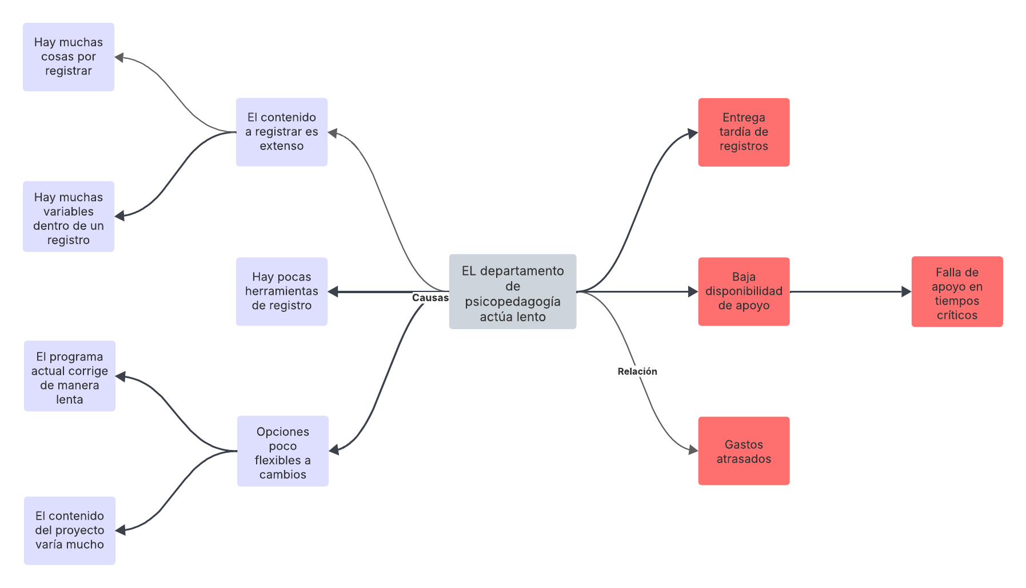
The problem of the slowness of the psycho-pedagogy department is not something new, being that a problem already seen for a long time which affects a lot to the people who needs the service.
Figure 1. Problem's tree diagram on the context of this project
In this figure we can see a problem’s tree diagram in which shows the designated effects on the past contexts. It’s important to mention that all the problems contribute to all the actions on a group and they are not isolated of each other.
In this we can see more directly the diverse origins that could be the cause of the setback of the direct services inside the diverse contexts, making the resolution of this problem very prioritized.

Idealization and creative ideas
Thanks to the figure 1 we can think on diverse solutions for the same problem.
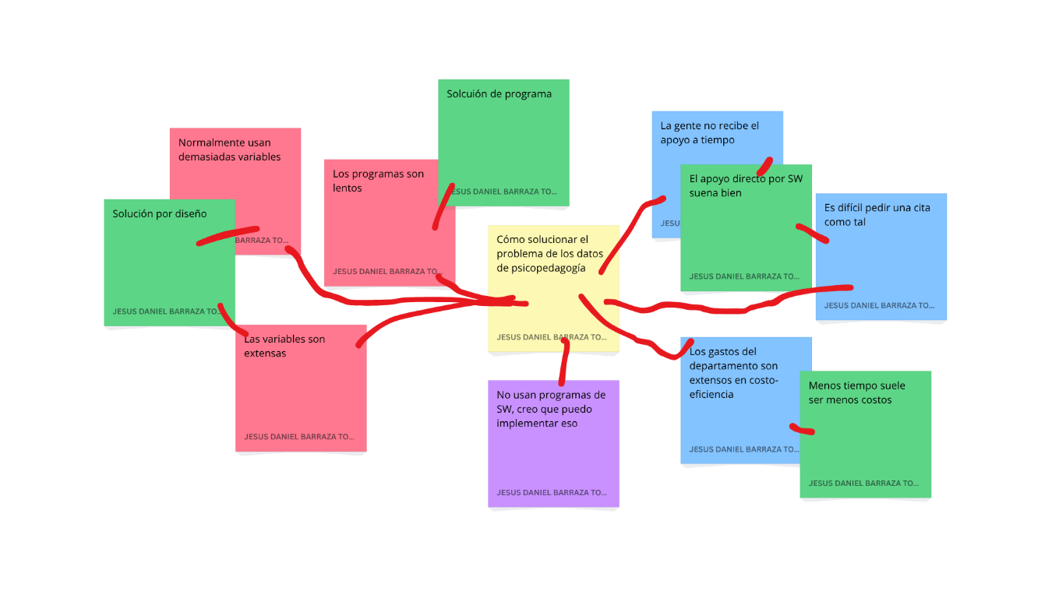
Since we have lots of problems related to the workload from the side of visualization one can assume that the most logical solution is the one where someone uses an application solution to solve the problem.
Figure 2. Brainstorming of the integrative project
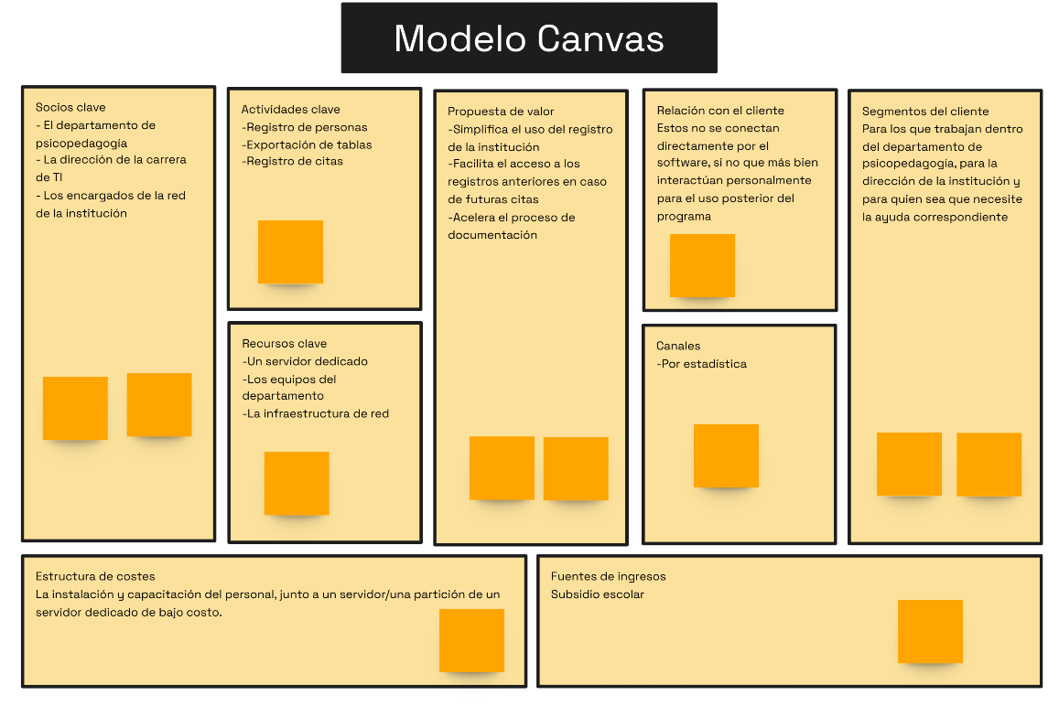
With that anyone could make the next diagram:
Figure 3. CANVAS model preliminary
With this diagram we can observe the resources that we have and we need for the implementation of the program.

SMART objectives and success criteria
Next, it will be presented some objectives via the SMART methodology with their success criteria:
Design a web-based appointment registration program:
- S (Specific): Design a desktop program for appointment registration, including the procedures required by the educational psychologist.
- M (Measurable): A tangible program that accesses a server.
- A (Achievable): It is feasible to develop a program based on the available paradigms.
- R (Relevant): It is the main project.
- T (Time-bound): Deadline: December 2025.
- Success Criteria: A nearly error-free program capable of registering and retrieving stored data; it must be fast, user-friendly, and contain the appropriate features.
Design a user manual:
- S (Specific): Design a user manual for the educational psychology program of UTD.
- M (Measurable): A tangible document, detailed enough to be at least 10 pages long.
- A (Achievable): A document developed alongside the program for user guidance.
- R (Relevant): Part of the main project, it is used to help the client learn how to use the software.
- T (Time-bound): Deadline: December 2025.
- Success Criteria: A grammatically error-free document that explains in simple Spanish how to use the program, includes illustrations to support the explanations, and provides evidence that the program works.

Project’s profile
On this table the project’s profile will be shown:
Project information
Name: Psycho-pedagogy program of UTD | Logo:  
Purpose: The project’s purpose is to bring a tool to the psycho-pedagogy department of the Technological University of Durango for the register of appointments and incidents on the institution.
Users: The workers of the psycho-pedagogy department.
Assumed: This project is presumed to be a significative upgrade on the attention of the psycho-pedagogy department.
Restrictions: We are restricted with the availability of the institution’s network; we are also restricted with the narrow worktime and the availability to find new ways.
Initial risks:
- At the beginning, the people on the department will not have the training for the data management.
- A flexible program with the use of Internet may suppose a more extended planning

Project planification

Project requirements
In order to fulfill the requirements, we need to get a project plan.

Prioritized list
A prioritized list is a way to organize the things that should/shouldn’t do in the project. Soon, it will be presented the points that will do in the project.
Must:
- The program must record data
- Easy-to-understand Visualization
- User manual written in simple language
- Properly structured document in Spanish
- Data export to an Excel file
Should:
- The program records data in a unified database
- Visually appealing interface for the client
- Technical manual
- Installation manual
- Properly structured document in English
- Program adapted to full-screen mode
- Data export to an Excel file with formatting
Could:
- The program records data from mobile devices
- Connection with Google Calendar, email, and SMS
- Installation executable
- The program exports data to a complete Excel document
- Adaptation to iOS
Won’t:
- The program records data from the internet
- Connection with variable programs
- Other types of manuals

Functional and non-functional requirements
Next, it will be presented the functional and non-functional requirements which will represent the things about the project:
Functional Requirements:
- The code saves data
- The code exports data
- Functions to insert, delete, display, update, and search/filter
- Create the desktop file
- Generate a complete manual
Non-Functional Requirements:
- The interface
- Confirmation messages for each action
- Export format
- Welcome and exit messages when logging in/registering

Acceptation criteria
The acceptation criteria are a set of conditions that a product, service or result must accomplish in order to be accepted formally. Now, it will be presented the acceptation criteria:
General: The program must work correctly, allowing the registration of dates and export the data on an Excel document.
Specific:
- Code: The code must work without errors, allowing us to register the dates on a database and export them on an Excel document.
- Design: The design must be simple and pleasant to the eye; the design must be able to use on an intuitive way and to be as little confusing as possible.
- Document: The document must be written on a simple and clear way.

Roadmap and initial strategy
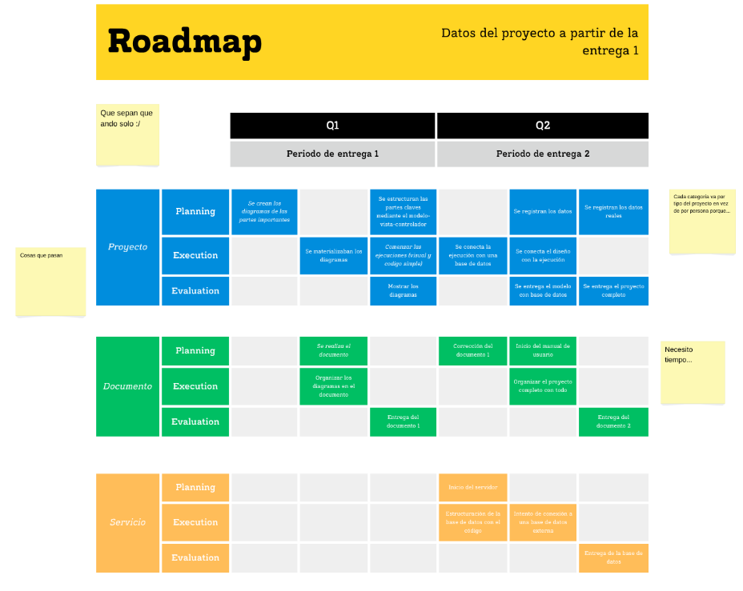
At this moment it will be presented the roadmap based since the first delivery.
Figure 4. Project's Roadmap
In this illustration we can observe the project’s roadmap. This allows us to visualize the plain objectives of both periods of general delivery of the integrative project. This data could be used more with the realization of all data said during the project’s share time.
In order to get an initial strategy of the project, one could research about the background within the project; in order to achieve this type of analysis, one could come up with a lot of analytics strategies to the project development as it is. Now, it will be presented the SWOT analysis oof the surroundings of the project:
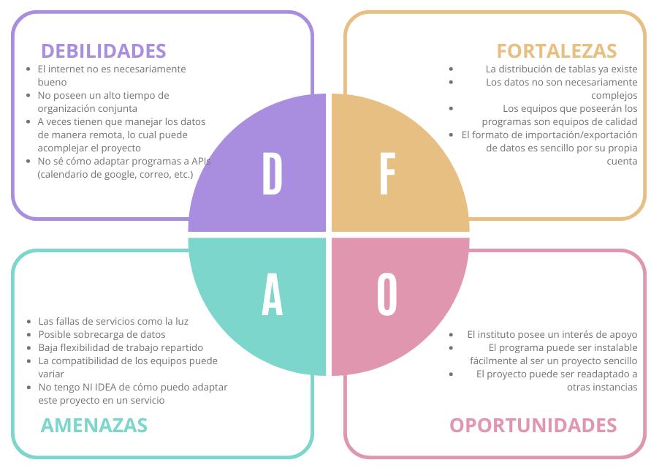
In this ilustration we can observe the project’s SWOT analysis. This analysis allows us to visualize the Weaknesses, Strenghts, Threats and Opportunities surrounding the integrative project.
Figure 5. Project's background SWOT analysis
With this analysis one could start the project on a comfortable way thanks to the visual and written guides that are presented to us.

Work Breakdown Structure (WBS)
The WBS is a visual tool that allows us to visualize the general and specific tasks that must be done on the project for their correct development. Now, the WBS diagram will be shown

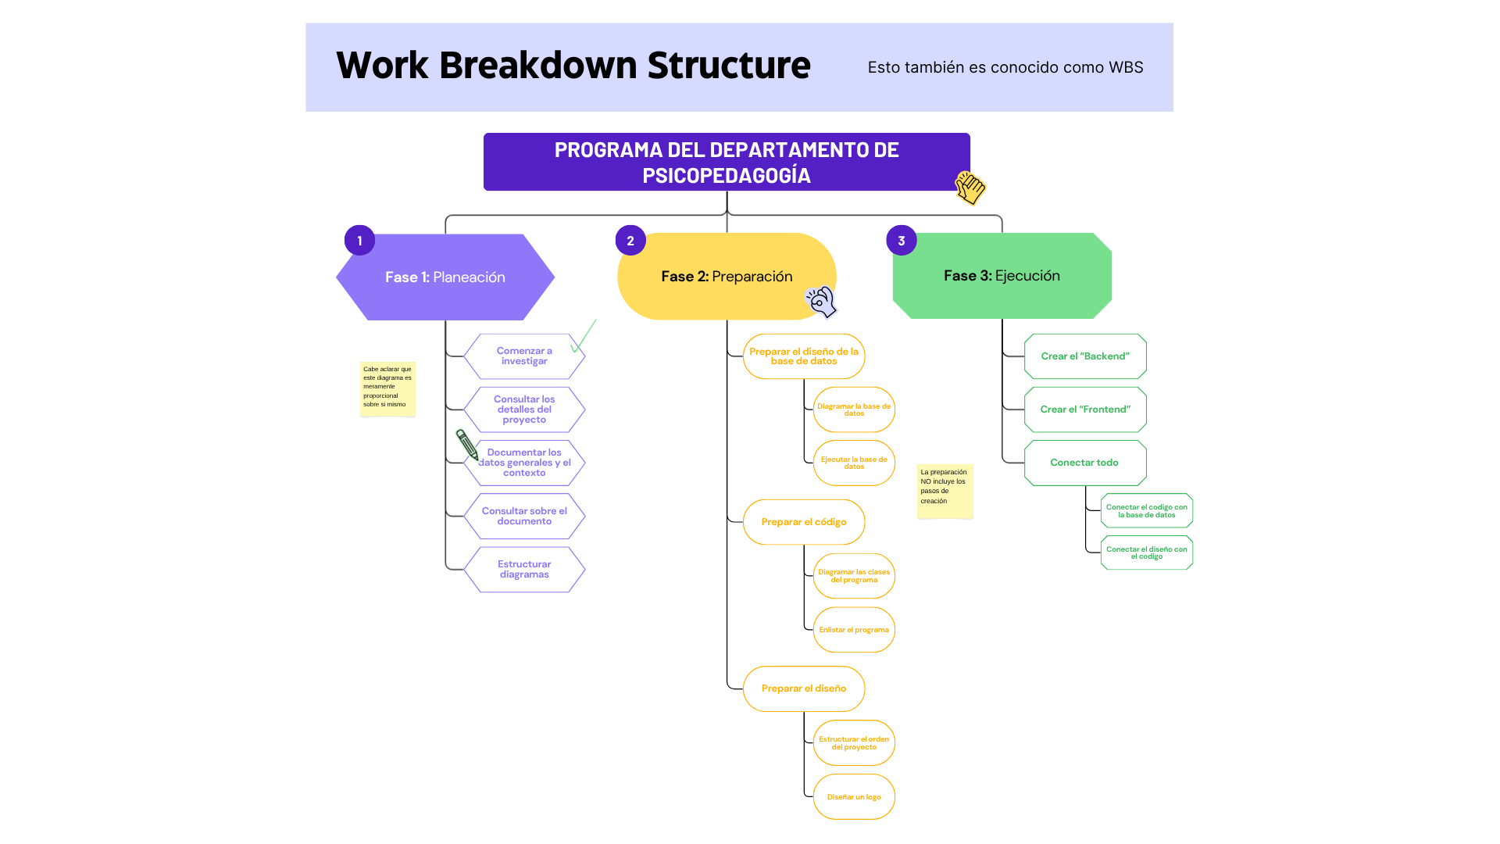
In this illustration we can observe the WBS diagram of the project. In this diagram we can visualize the 3 main stages of the project that will allow us the project realization properly. This project is divided on 3 stages: Planning, preparation and execution. These phases are divided by their areas and things to do.
Figure 6. Project's WBS diagram

Chronogram
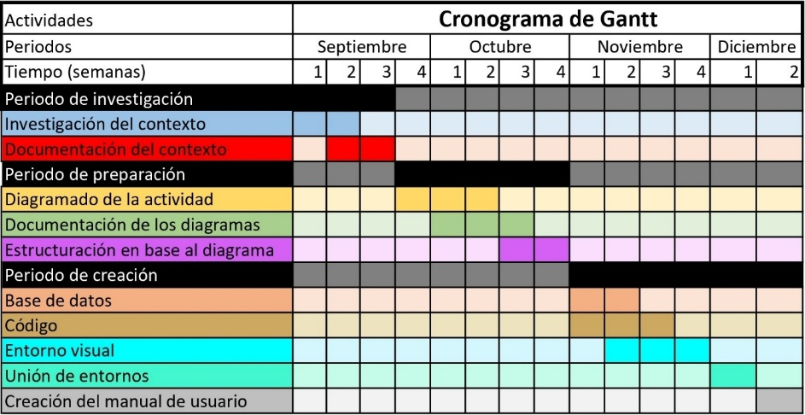
Now, it will be shown the Gantt chronogram regarding this project:
Figure 7. Gantt's chronogram of project
In this illustration we can observe the Gantt’s chronogram of the project. In this diagram we can see every illustration with the corresponding parts of the project as it is.
Thanks to the illustration we can see the time used in periods.

Resources and budget
To determine the resources and budget for this project, one can identify the resources that are available
For the resources, everything is accounted for as follows:
- Internet provided by the university in question
- Existing and functional computer equipment
- Previously known notes and tables
- Possible existing servers
The available budget is unknown due to a lack of specification in the project.

KANBAN board and Done Definition (DoD)
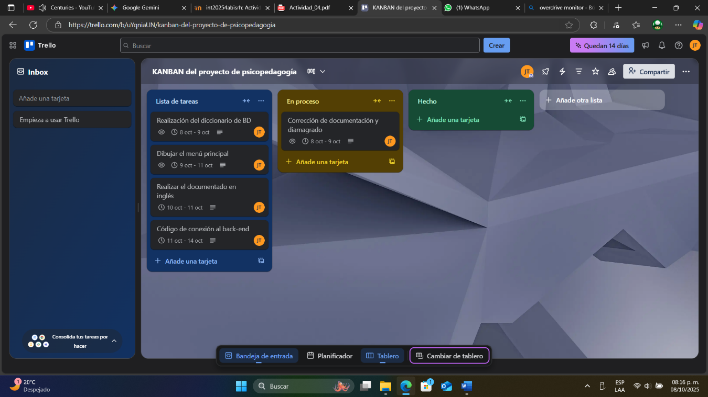
The Kanban board is an activity board that allows the work distribution by member. Now, it will be shown the start of the board by the first day:
Figure 8. Project's day 1 Kanban board.
In this illustration we can observe the KANBAN board on the day the project started (8/10/25). At the time there was only 5 tasks that should be done in order to make the project for the early period, this is because there wasn’t a clear compass as it is about what to do.
Figure 9. Project's last day Kanban board.
Now, we will show the final date:
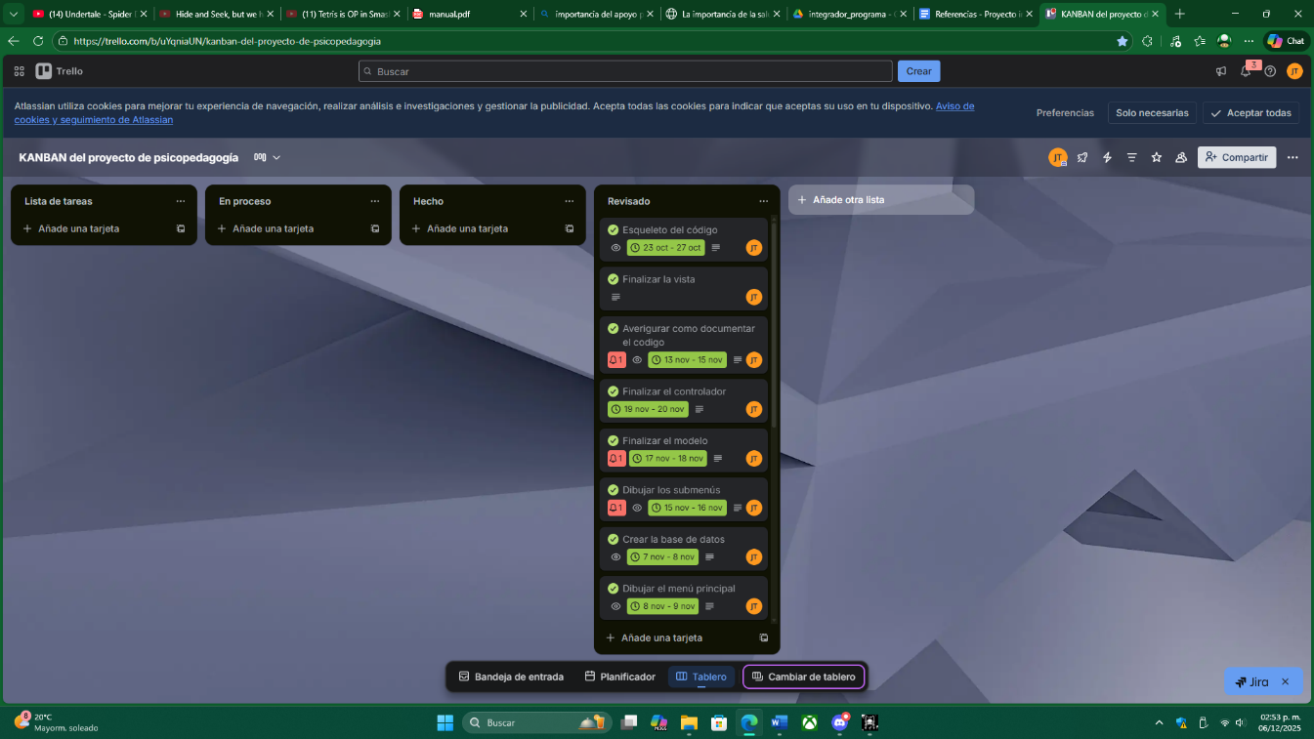
[Incomplete]
In order to correspond the done definition of every task we based 3 main characteristics:
- That works
- That is easily readable
- That is able to integrate on the project as it is.

RACI matrix and risks
The RACI matrix allows the division of project responsibilities among the team into the following roles: Responsible, Approver, Consulted, and Informed. Unfortunately, since this project is carried out by only one person, that individual is responsible for all aspects of the project, making the creation of this matrix impossible.
The risks, previously mentioned in the SWOT analysis, consist of factors that may hinder the creation and/or continuation of the project. The analyzed risks are:
- The internet connection is not necessarily reliable.
- There is limited time for joint organization.
- Data sometimes has to be managed remotely, which can complicate the project.
- I don’t know how to adapt programs to APIs (Google Calendar, email, etc.).
- Service failures such as power outages.
- Possible data overload.
- Low flexibility for distributed work.
- Equipment compatibility may vary.
- I have NO IDEA how to adapt this project into a service (probably not very feasible).

Design, development and proof

Architecture and Solution Design

Architecture Design
The architecture design is a type of diagram that allows the visualization of the program within its scope. One of these diagrams is known as the deployment diagram, which allows marking interfaces and actions within the application distributed across a physical area.
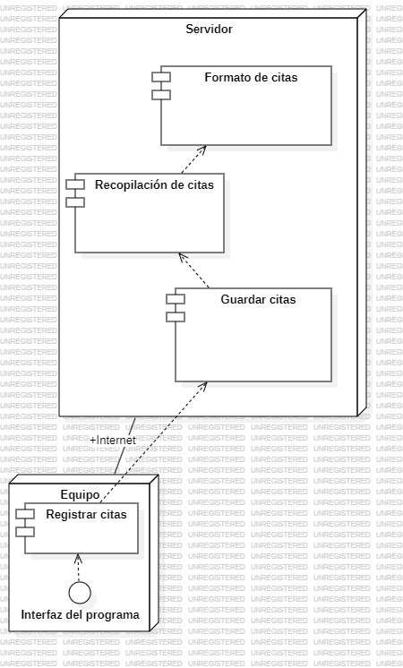
However, due to the simple structure of the program, it can be represented in a straightforward manner, as shown below:
Figure 10. Architecture's diagram (distribution's diagram)
In this illustration, we can observe an architecture diagram, also known as a deployment diagram. Here, the program interface is located entirely on the user's device, which sends its data to a dedicated server that stores, compiles, and formats the appointment records.

Chosen Technologies
The technologies selected for this project are the following:
- Flet in Python
- MySQL database

Justifications
The following technologies were chosen due to:
- Flet in Python
  - Felt has lots of tools in creating complex designs.
  - Flet has lots of modifying tools for complex designs
  - It works well with other dependencies.
  - It is easy to test and debug.
  - It is lightweight and simple to use.
- MySQL Database
  - It is relational, as only variable-based data is handled.
  - It is easy to understand.
  - It is secure for data storage.
  - It allows storing long data strings.

Functional Modeling

Use Cases
A use case diagram visually represents how a program operates, either through a single function or the entire application. Below, the program’s flow diagrams are presented:
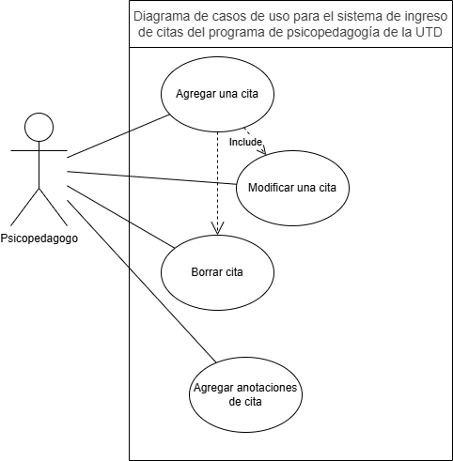
In this illustration, we can observe the use case diagram for the appointment entry system of the UTD psychopedagogy program. This diagram shows the appointment registration, modification, and the entry of appointment diagnoses.
Figure 11. Diagram for the appointment into

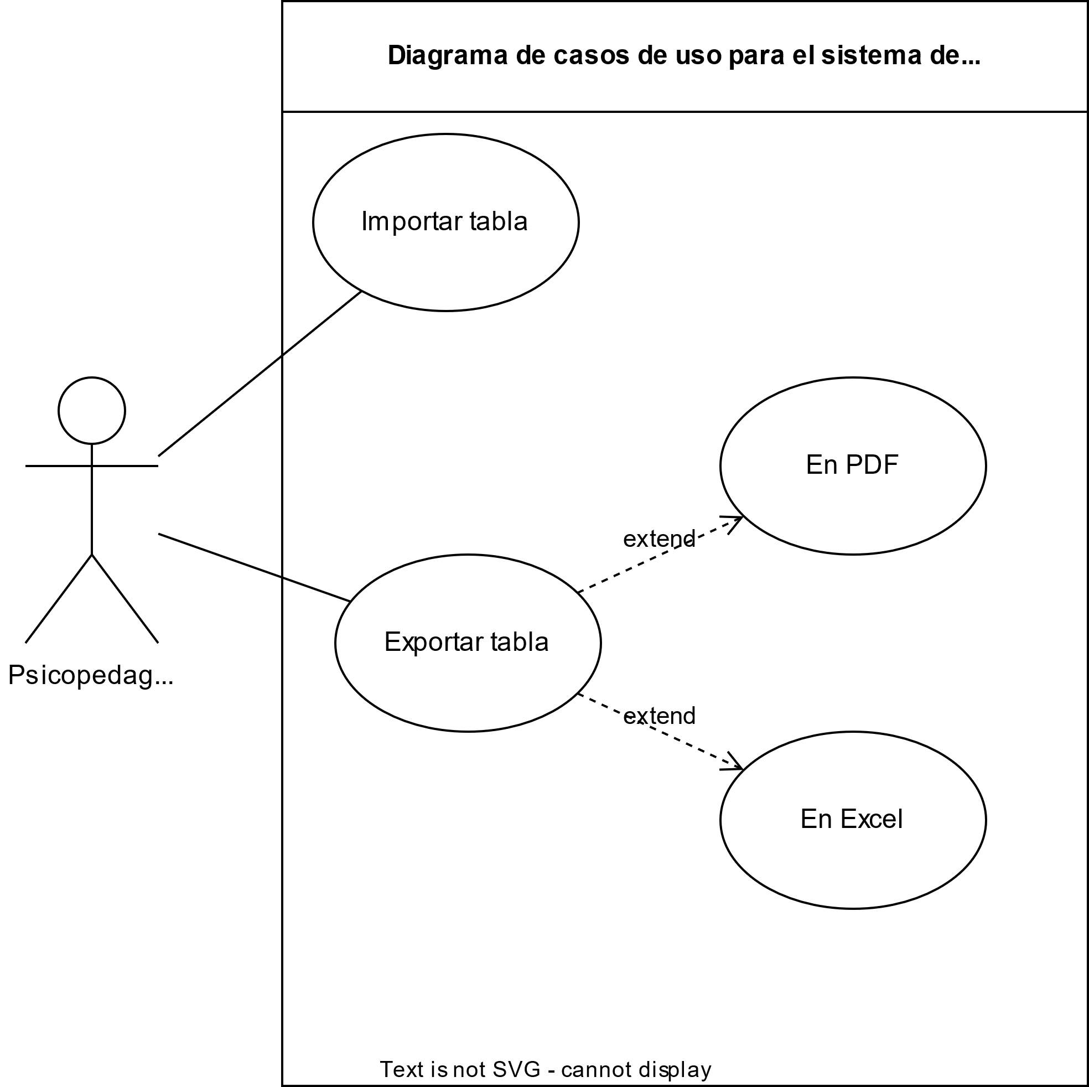
In this illustration, we can observe the use case diagram for the data import/export function of the UTD appointment program. This diagram demonstrates the different formats to which data can be exported based on specific dates.
Figure 12. Diagram about the import and export of excel sheets
More flow diagrams can be found in section 10.

Wireframes / UI
A wireframe is a visual representation of a page/application under development before transitioning to actual code. This part is essential for the design of interface-related elements.
This project was developed using Flet, a popular wireframe tool that visually displays the program structure. Below is one of the application's pages.

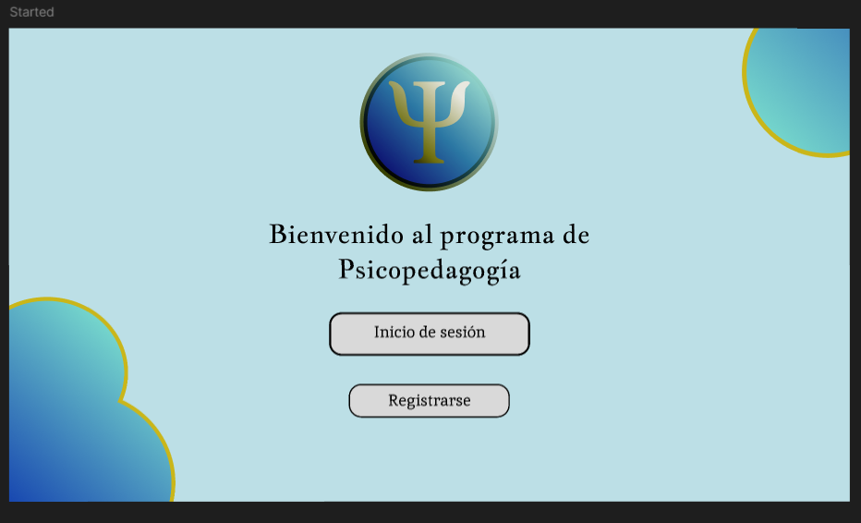
In the illustration, we can observe the login page of the psychopedagogy program within the wireframe. This interface is essential for logging in and registering within the system.
Figure 13. "Started" page on the program's wireframe
To view the complete wireframe, click on the image or click here.

Usability Guidelines
Usability guidelines are standards that prioritize certain principles for the use of a program, ensuring optimal usability throughout the project.
The usability guidelines of this project focus on the user’s ease of use within the program. This means the product must be intuitive and simple to operate for managing appointments.
These guidelines apply to all system components: main screens, submenus, input functions, communication modules, and visualization screens.
The interface will maintain the institution’s branding colors alongside some general colors: blue, gold, white, and black. Additionally, a specific font will be used across the system.
After logging in, only the appointments belonging to the active user will be displayed. Whenever there is a view containing multiple records (appointments, students, or tutors), a visible search bar must always be present along with its functional tools.
Messages displayed in prompts and submenus must be clear, showing relevant and important actions.
Excel or PDF documents must be readable and exportable correctly in the event of data loss in the database.
The system will be evaluated by the psychopedagogy department for the project's continuation.

Coding Standards and Repository

Code Conventions
Code conventions define the standards the project will follow during its development.
The project structure follows the Model-View-Controller (MVC) pattern. This layer-based architecture separates the “view” (user interface) and the “model” (database logic), both of which interact through the “controller.”
Naming styles throughout the codebase are:
- Classes: PascalCase → AlumnosRegistrados
- Functions: camelCase → insertarCita
- Variables: snake_case → nombre_completo
Indentation will be used to show what belongs to conditionals, loops, functions, or classes.
There is no limit to line length; sections will adjust as needed.
Good coding practices will be followed across the entire project.

GitFlow Branching
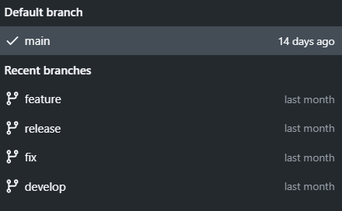
Repository branches allow organizing changes and features independently.
Figure 14. Program's git branches
In this illustration, the Git branches are shown. They are categorized as follows:
- Main: Main branch, containing the production-ready program.
- Feature: Branch used for program updates.
- Release: Branch for final program versions.
- Fix: Branch for bug resolution.
- Develop: Branch for new feature development.

Commit Messages
Commit messages document updates pushed to the repository with useful and structured information.
The structure is as follows:
Title.
Detailed description of the changes.
Tags used throughout commits include:
- Fix: Bug fixes
- Feat: New features
- Docs: Documentation improvements

Code Documentation
Code documentation is a good programming practice that allows developers to understand function/class purposes when reviewing or modifying code.
The documentation structure will be as follows:
#Comment
Function or group of functions
Implementation

Incremental Implementation

Splint logs
- Sprint Log 1 – Initial Documentation
  - Duration: October 1–15
  - Objective: Document as much as possible before coding.
- Planned Activities
  - Create all required diagrams before starting.
  - Document everything before making any project changes.
  - Determine how to track significant changes for future meetings.
- Activities Completed
  - Work was done two weeks after the planned completion date.
- Challenges
  - Personal issues not relevant to the project.
- Solutions
  - Work pace was slowed for better management, including personal difficulties.
- Deliverables
  - This document (up to chapter 3)
  - Additional diagrams not included in this document
  - Interview and document submission
- Sprint Log 2 – Visual Delivery
  - Duration: November 1–15
  - Objective: Deliver a stable visual design for later implementation.
- Planned Activities
  - Complete the wireframe
  - Show interaction between all interfaces
  - Build the Excel formats
- Activities Completed
  - Completed the wireframe
  - Displayed interactions between interfaces
- Challenges
  - Heavier-than-expected interface design caused longer loading times
  - Personal difficulties
- Solutions
  - Export design was kept consistent with earlier versions
  - Work was done at a slower and more manageable pace
- Deliverables
  - Wireframe link
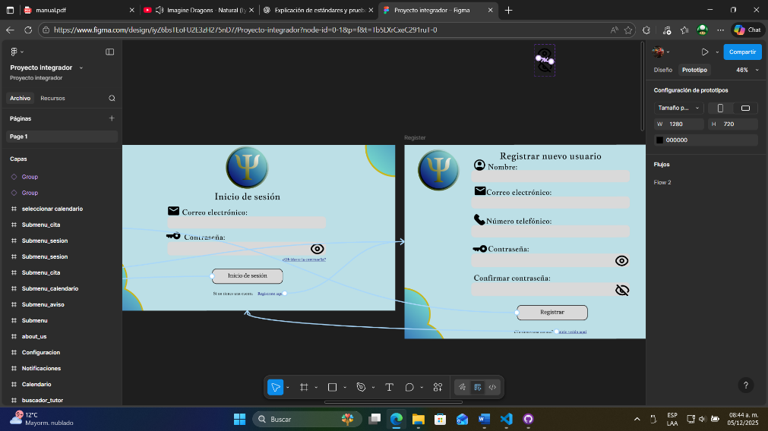
- Evidence
Figure 15. Project's wireframe evidence
The following illustration shows a screenshot of the wireframe with visible program interactions.
- Sprint Log 3 – Code
  - Duration: November 1–3
  - Objective: Develop the code once documentation was complete.
- Planned Activities
  - Finish the code
  - Document the code
- Challenges
  - Learning many concepts at once made understanding difficult
- Solutions
  - Personal methods not relevant to this document
- Deliverables
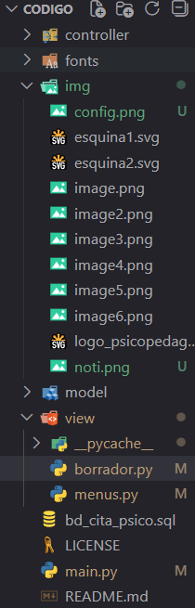
  - The code
Figure 16. Spring logs 3.2 evidence
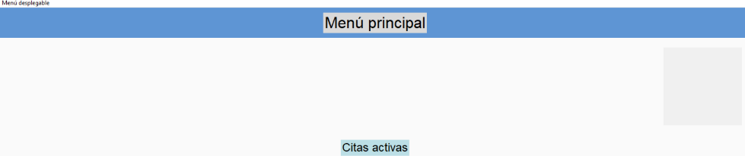
Evidence:
Figure 17. Springlogs 3.1 evidence
The following illustration shows:
- The beta design of the main menu
- A screenshot of Visual Studio Code showing the project files

Test Plan

Strategy
The test plan is divided according to standard software evaluation methods:
- Unit Tests: Conducted during function development
- Integration Tests: Some modules tested during development; others separately
- System Testing: Performed in a single full run and properly documented
- UX Testing: Conducted by the psychopedagogy department and external testers

Test Cases
Case | Action | Input | Expected Result
RE01 | Register | Valid input | Registers correctly
RE02 | Register | Invalid input | Shows error message
IS01 | Login | Valid input | Logs in successfully
IS02 | Login | Invalid input | Shows error message
IS03 | Login | Incorrect credentials | Warns that the login is incorrect
EX01 | Export | Normal export | Exports data
EX02 | Export | Empty export | Outputs an empty file
EX03 | Export | Invalid export | Shows an error warning
CH01 | Contact | Send something | Message is sent
CH02 | Contact | Send nothing | Sends an empty message or sends nothing

Tools
Currently, no external tools are used; tests are recorded manually. You may view the test recordings and the obtained information through the link provided.

Test Results and Performance Indicators

Reports
Reports are files that track errors during execution. Since tests have not fully been performed, there are no reports at this time.

Bugs
Description | Reproduction | Severity | Status
Submenus do not work | Opening a submenu | High | Fixed
Submenus do not display data | Opening a submenu | High | Fixed
Add appointment button does not work | Main menu when no appointments exist | Low | Fixed
Won’t register appointment | Registering an appointment for a student added by someone else | High | Under review

Coverage
The test coverage is approximately 76%, meaning some invalid cases and multi-account scenarios were not tested. All main processes were tested.

Performance Metrics

Performance
- The program takes 2.5 seconds to open, plus a 3-second loading screen.
- It uses approximately 0.38 Hz of CPU and 100 MB of RAM.
- It can handle multiple users when using a dedicated database server.

Usability
- According to testers (including the psychopedagogy department), the program is intuitive and its processes are easy to follow.
- It was built following a low-clicks-required methodology.

Reliability
- Unfortunately, the failure rate is high.
- Simple recovery methods exist (file-based backups).
- Time between failures remains significant.

Adaptation, validation and divulgation

Changes gesture and improvements
The change gestures and improvements are the process which it’s evaluated, approved, implemented and documented modifications on the project

Changes request
A change request is a formal petition for the modification of an element’s project. In this project’s case we had 2 fast requests by the psychopedagogy department:
- The program exports a formatted Excel
This is because they need to give to the superior institutes on a specific Excel format.
This would affect the exportation method (mainly the code).
URGENT
- The program communicates with the tutors
A request for the department’s chief which has difficulties to contact with the tutors.
This would affect the complete code, adds at least 1 more screen and changes how some modules work.
This is just 1 more function, it’s not that urgent.
The evidences of these change requests are on audios here.

Impact analysis
The impact analysis applies to a request in order to apply taking in consideration expenses both monetary and time and other things that affects from the integrative project to the people doing it.
First request:
This is a project with low changes by the code, modification and so on. It’s relatively easy to implement and doesn’t require extra programs in order to work so it’s easy to do.
Final decision: approved.
Second request:
This is a heavier request. Requires a constant internet conexion for it to work, along with the process that’s needed to work (code’s not getting more complicated). In case of the chat needed we must use whatsapp (it’s hard apparently). At the moment it isn’t done yet.
Final decision: postponed

Socioemotional management and ethics

Leadership and collaboration
This project, made by 1 person, doesn’t have the requirements to be judged by the leadership and collaboration part. The personal opinion stuff about the performance can be found on 7.2.

Sustainability and social responsibility
This project doesn’t affect in almost any way the nature because it was developed in order to be used on the already existing electrical and electronical structure.
This project was molded for both the program’s usability by the psychologic department and the management of sensible data as good as possible. However, it’s important to clarify that the first security layer is the human security and there’s a risk of data steal or information loss and, by that, there’s precautions to take.

Ethical frame and security.
This project takes the necessary data for the psychology department, but they’re stored directly on the server services and not inside the program.
Compilation, exportation and/or import of data are used by the psychology department, which send them directly into the education’s secretary, “Universidades tecnológicas y politécnicas” and others which uses the data on their own ways.
It’s important to clarify that the first security layer is the human security and there’s a risk of data steal or information loss and, by that, there’s precautions to take.

Evidences portfolio
Figure 1. Problem's tree diagram on the context of this project 12
Figure 2. Brainstorming of the integrative project 13
Figure 3. CANVAS model preliminary 13
Figure 4. Project's Roadmap 18
Figure 5. Project's background SWOT analysis 19
Figure 6. Project's WBS diagram 20
Figure 7. Gantt's chronogram of project 20
Figure 8. Project's day 1 Kanban board. 21
Figure 9. Project's last day Kanban board. 22
Figure 10. Architecture's diagram (distribution's diagram) 25
Figure 11. Diagram for the appointment into 27
Figure 12. Diagram about the import and export of excel sheets 28
Figure 13. "Started" page on the program's wireframe 29
Figure 14. Program's git branches 31
Figure 15. Project's wireframe evidence 33
Figure 16. Spring logs 3.2 evidence 34
Figure 17. Springlogs 3.1 evidence 34
On this list we can see 17 figures which we can see inside the document. About this:
- 1-5 figures are with the unit 1
- 6-9 figures are with the unit 2
- 10-17 figures are with the unit 3
- Unit 4 figures are inside this folder.

Own’s checklist
4 puntuation | This was done as usual
3 puntuation | This was done with some difficulties
2 puntuation | This was done with much difficulties
1 puntuation | This was not made
In case of being able to mention the management during the realization of the project I could say a 2 (10.0). This project of 1 person needs just more time in order to be made normally.
Even with the initiative, it’s important to clarify the resources and knowledge are important, in spite of this, this project was made with a bit of time and with low knowledge for just 1 person.
There won’t be any comment about personal affairs because of the project’s difficulty and the formality margin in which this is done.

Conclusions and future work

Achievements vs objectives
In this project there’s not much to say. An appointment’s program was made, despite of this, there are things that wasn’t finished:
- There’s a lot of the visuals missing.
- You cannot contact with others still.
- There are still bugs.
Basically, the project is still open.

Limitations and next steps
One of the limits inside the project is that it was made by just 1 person, which means the time working on the project is as hard as it could be.
Other limit, mentioned before, is the lack of knowledge that I had at the moment of the start of the project.
Because of that, I will put the next steps for this project:
- Finist the visual bugs on felt
- Fix bugs
- Add the contact functions.

References and normatives
References
American council of education. (2025, Abril). KEY MENTAL HEALTH IN HIGHER EDUCATION STATS. https://www.acenet.edu/Documents/Mental-Health-Higher-Ed-Stats.pdf
Atherton, H., & atherton, h. (2024, Julio 8). Investigating Patient Use and Experience of Online Appointment Booking in Primary Care: Mixed Methods Study. PubMed Central. https://pmc.ncbi.nlm.nih.gov/articles/PMC11263895/
Avalos-Bravo, V., & Torres Rivera, A. D. (2022, Noviembre 11). Digital Transformation of Higher Education: Mexico City-IPN as a Practical Case. Research-Gate. https://www.researchgate.net/publication/364936461_Digital_Transformation_of_Higher_Education_Mexico_City-IPN_as_a_Practical_Case
de Vries, W., & Álvarez-Mendiola, G. (2024). The effects of ICT on Higher Education in Mexico. OJED. https://files.eric.ed.gov/fulltext/EJ1427072.pdf
Education at a Glance 2023. (2023). Country note - Mexico. https://gpseducation.oecd.org/Content/EAGCountryNotes/EAG2023_CN_MEX_pdf.pdf
Education at a glance 2024. (2024). Mexico. https://www.oecd.org/content/dam/oecd/en/publications/reports/2024/09/education-at-a-glance-2024-country-notes_532eb29d/mexico_40647691/7376478c-en.pdf
Healthy Minds Study. (2024). The healthy minds study. https://healthymindsnetwork.org/wp-content/uploads/2024/09/HMS_national_report_090924.pdf
La depresión. (n.d.). Importancia de la ayuda psicológica: La salud mental como prioridad. Que es la depresión. Retrieved octubre 6, 2025, from https://queesladepresion.com/importancia-de-la-ayuda-psicologica/
Universidad Nacional de Avellaneda. (2024, Julio 16). La importancia de la salud mental en el entorno universitario. ADN UNDAV. Retrieved Diciembre 6, 2025, from https://adn.undav.edu.ar/la-importancia-de-la-salud-mental-en-el-entorno-universitario.html
Universidad Tecnológica de Durango. (n.d.). Departamento de Psicopedagogía. Manual de organización. Retrieved octubre 6, 2025, from https://www.bing.com/ck/a?!&&p=197041db942b2ddd872665f0da47423adcf3d3a1786e8a709bbf55903ea7518cJmltdHM9MTc1OTcwODgwMA&ptn=3&ver=2&hsh=4&fclid=23df959f-423b-6b07-24e2-83e7431e6a19&psq=universidad+tecnologica+de+durango+departamento+de+psicopedagog%c3%ada&u=
Woodcock, E. W., Zhao, P., & O'Donnell, A. (2022, Enero 11). Barriers to and Facilitators of Automated Patient Self-scheduling for Health Care Organizations: Scoping Review. PubMed Central. https://pmc.ncbi.nlm.nih.gov/articles/PMC8790681/
You can see all the project here.

Template matrices

Matrices and templates
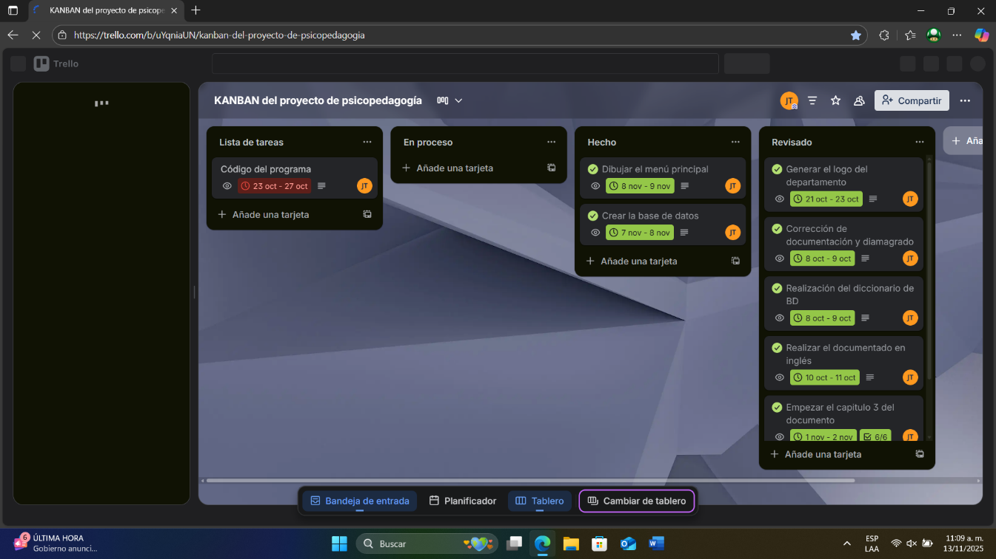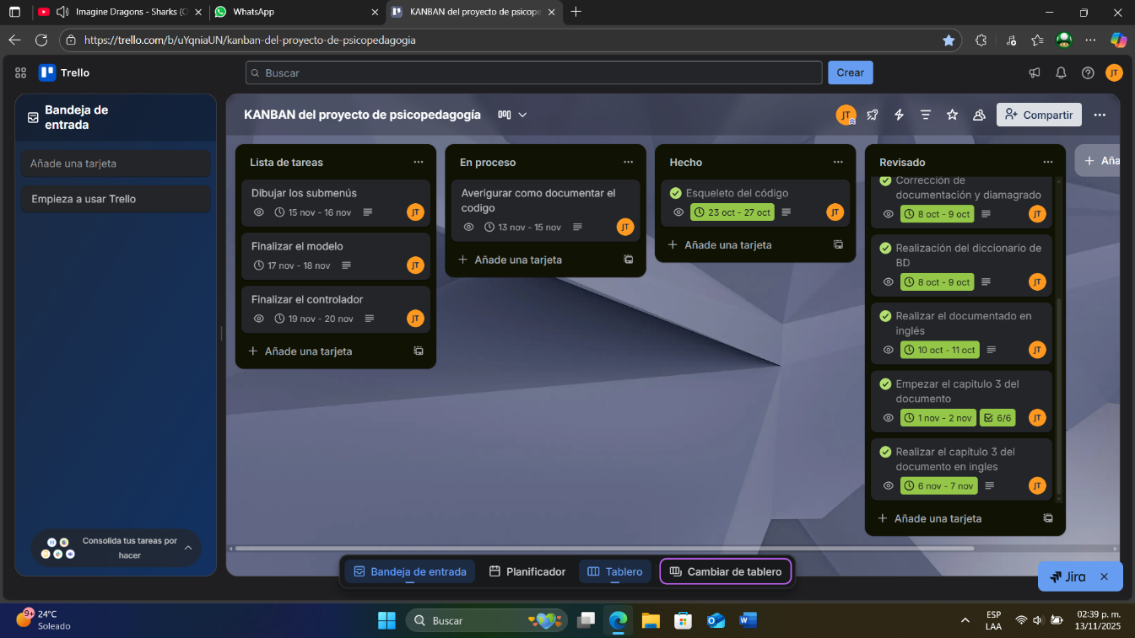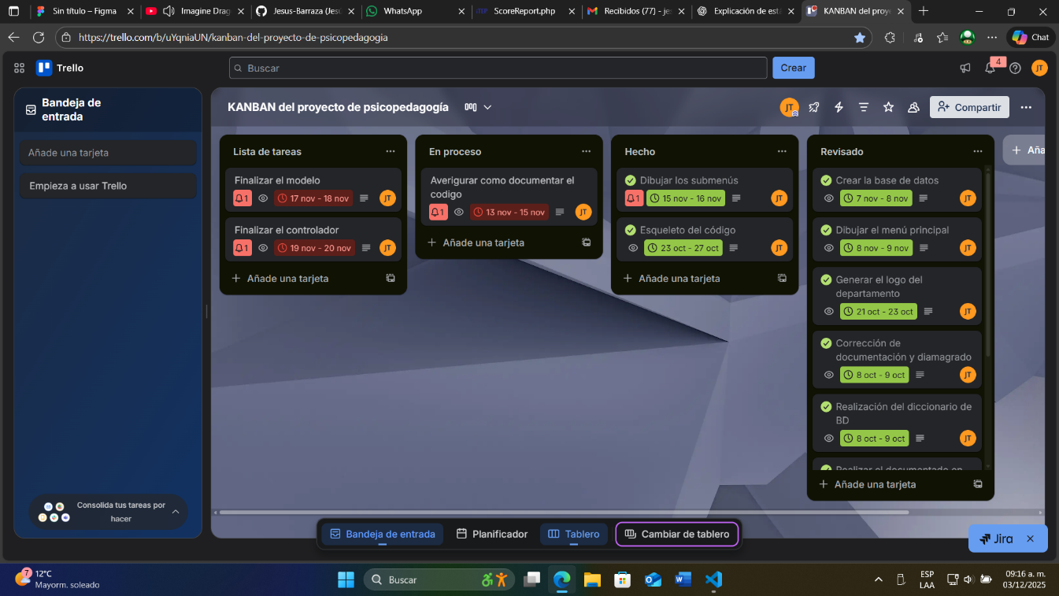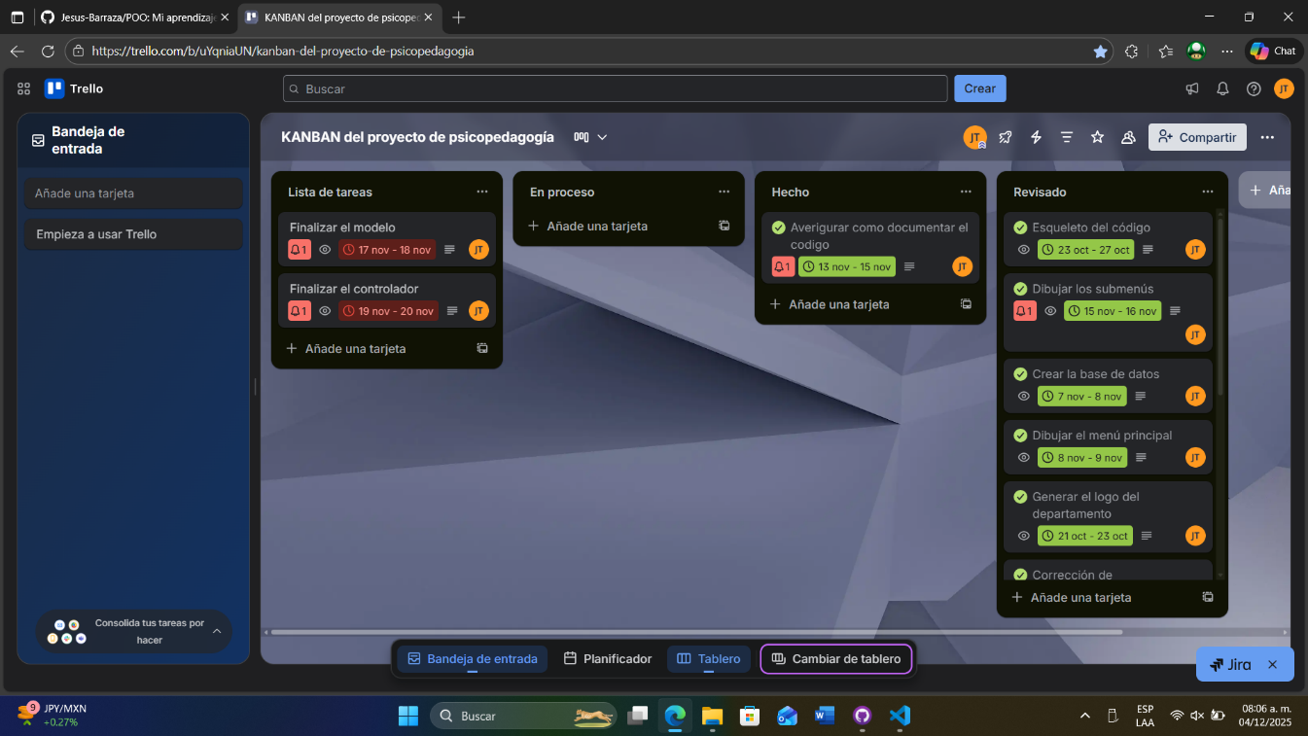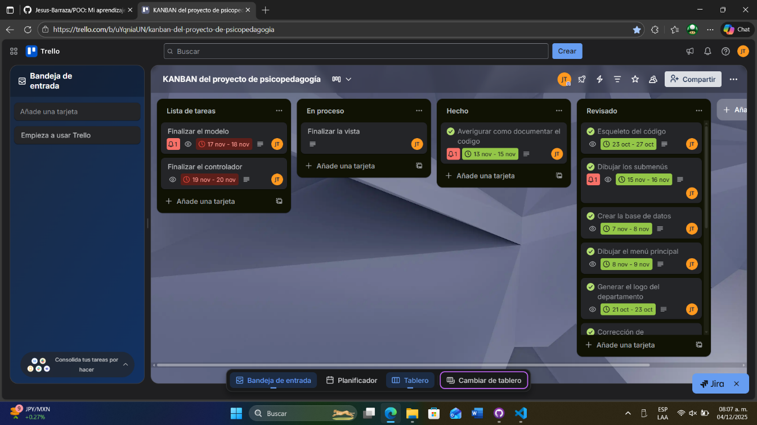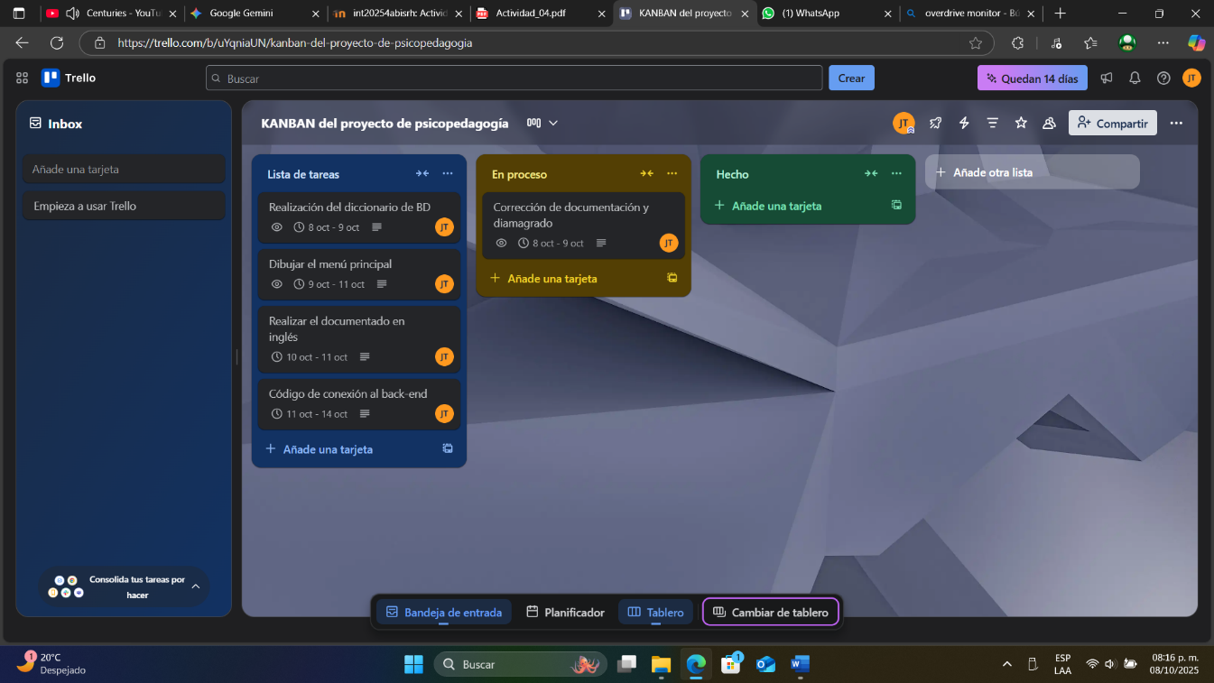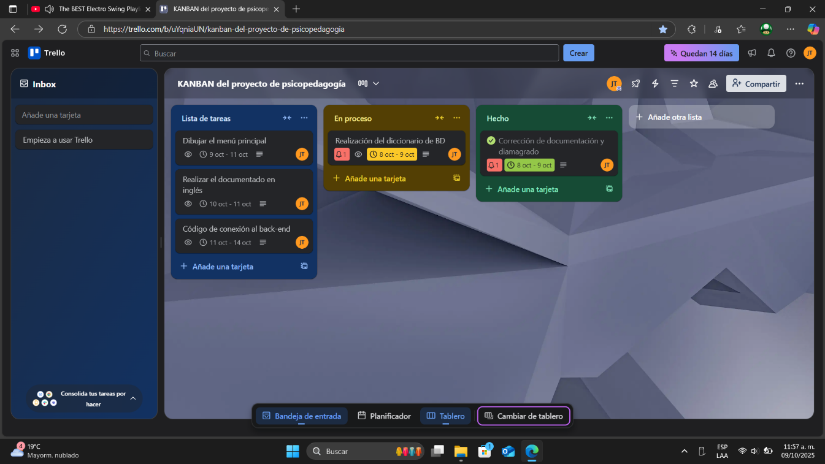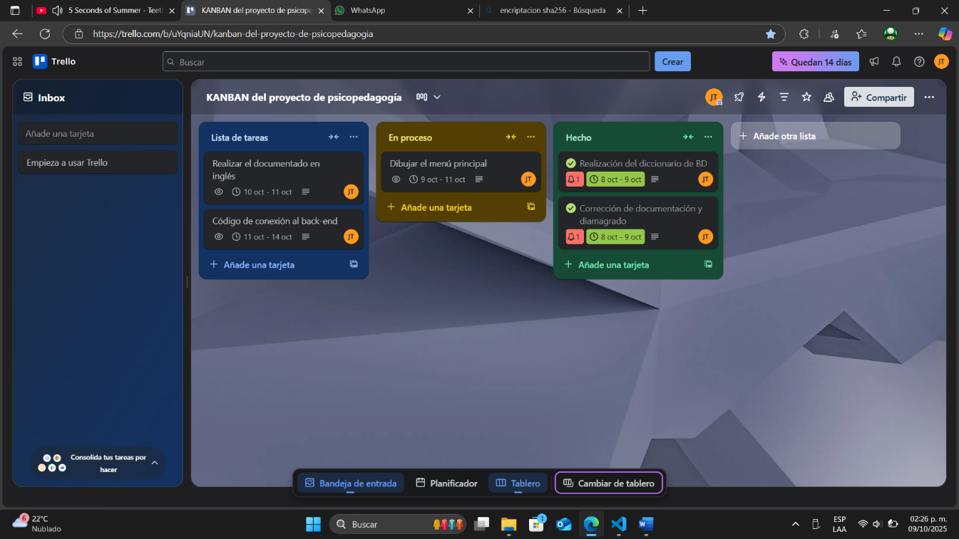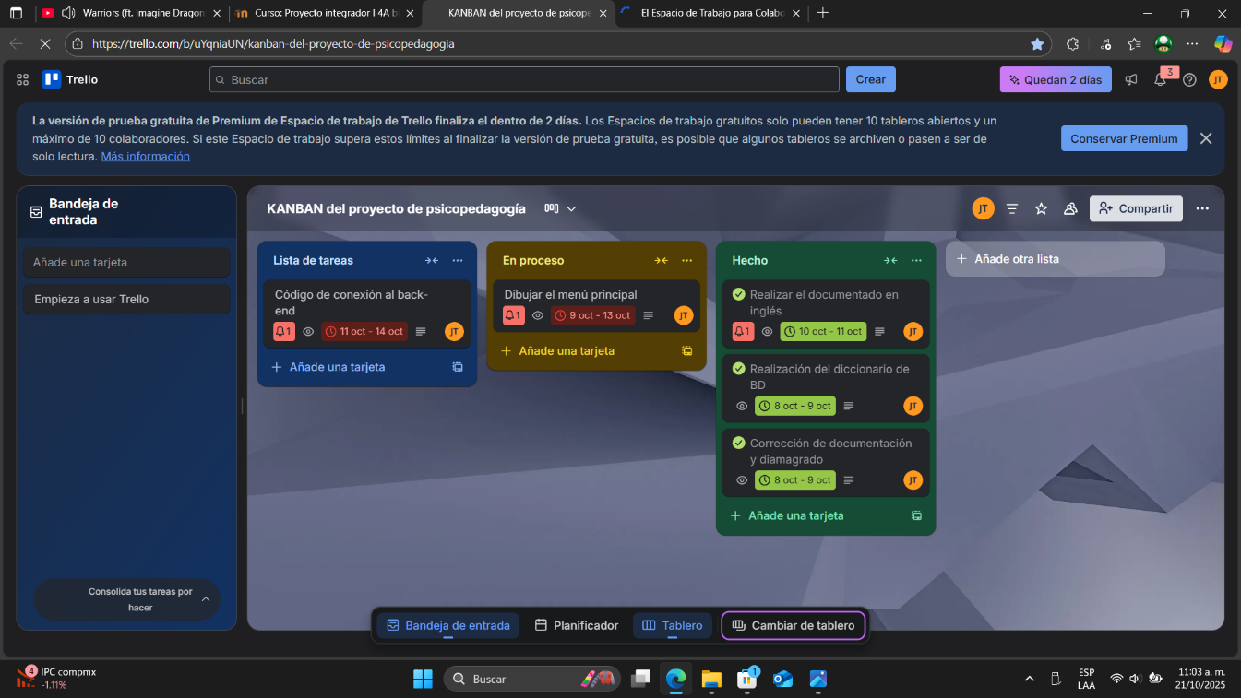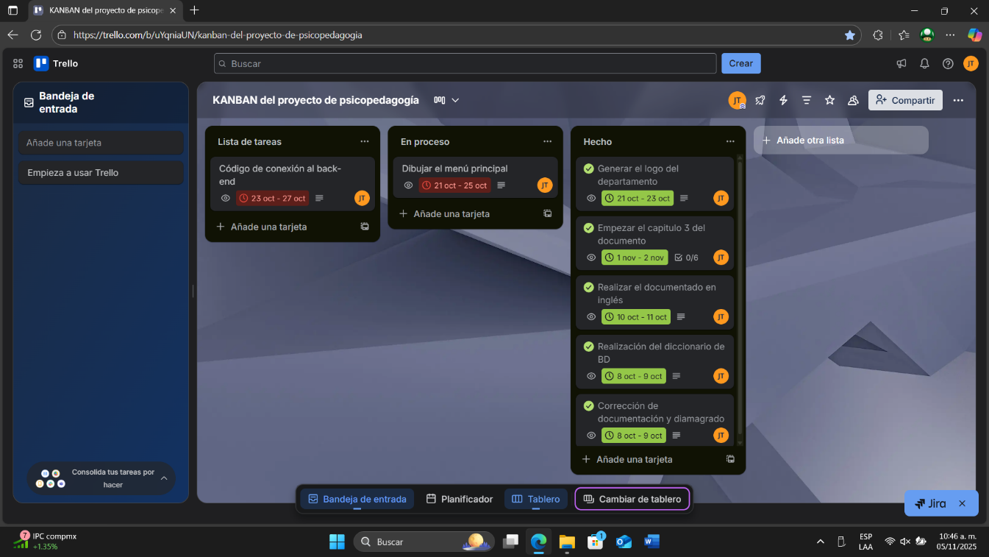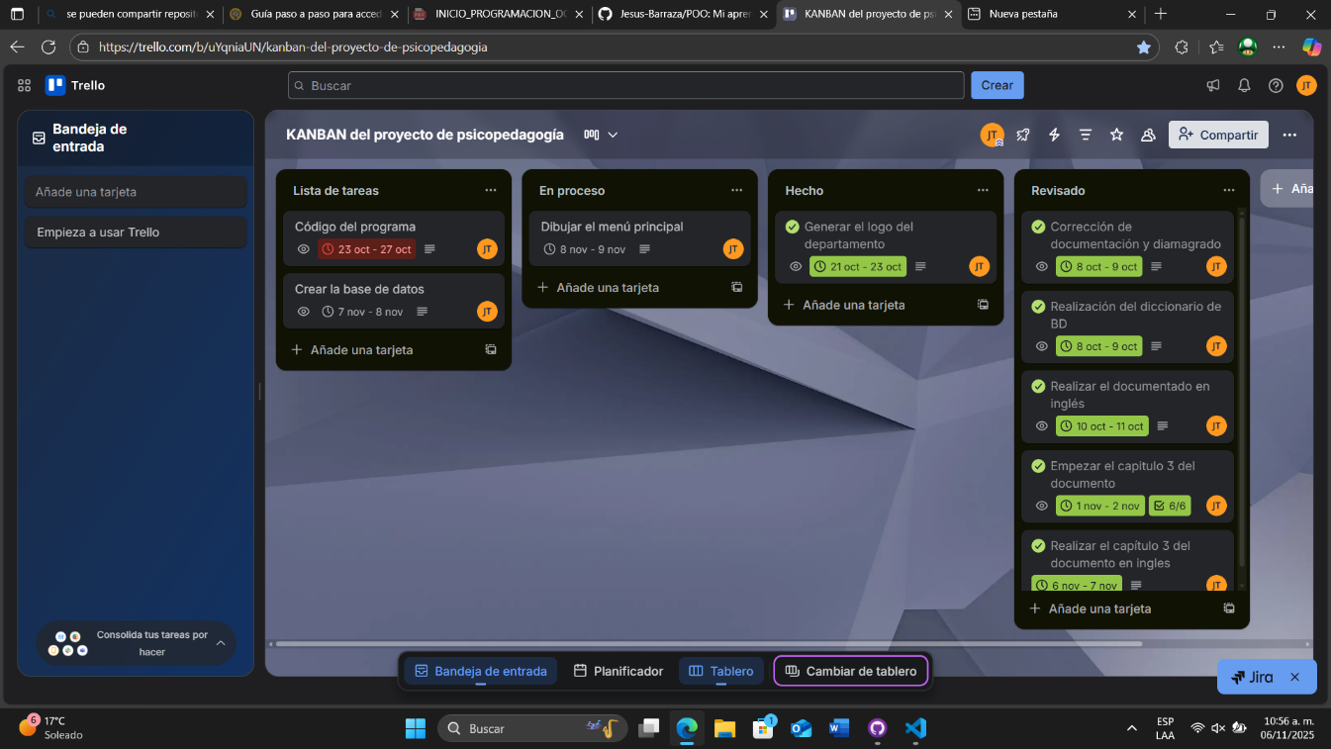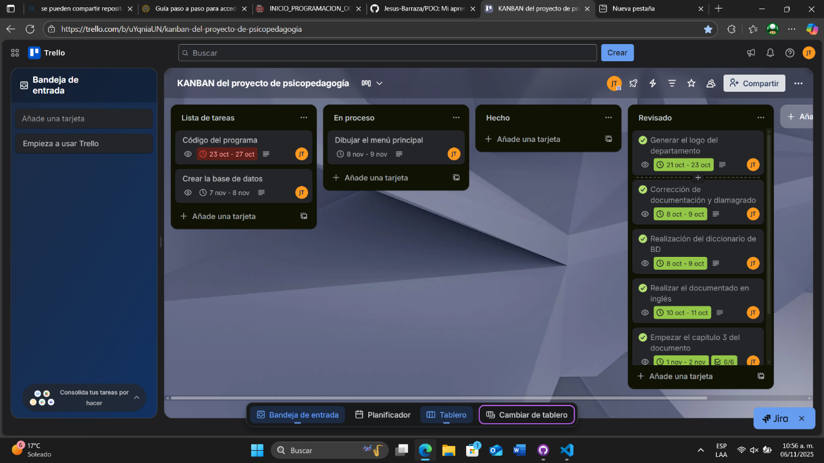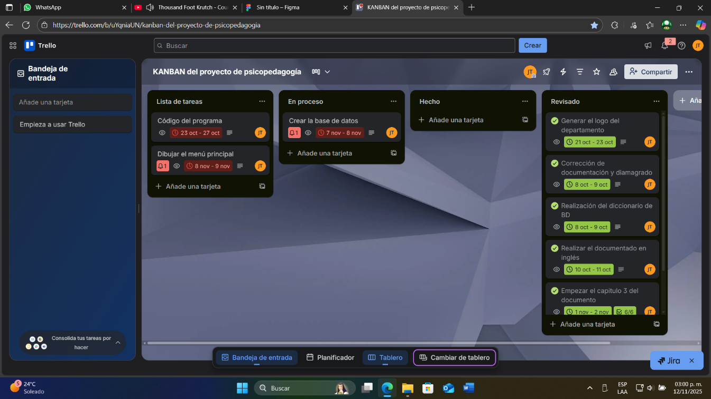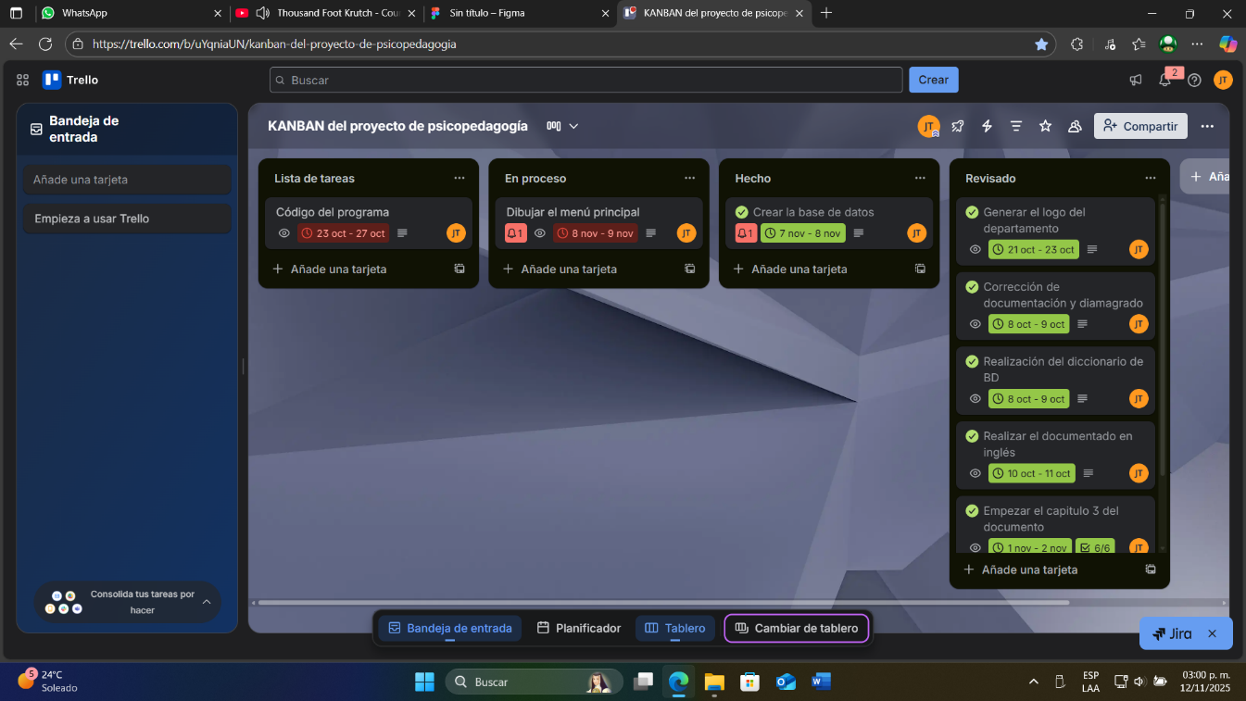
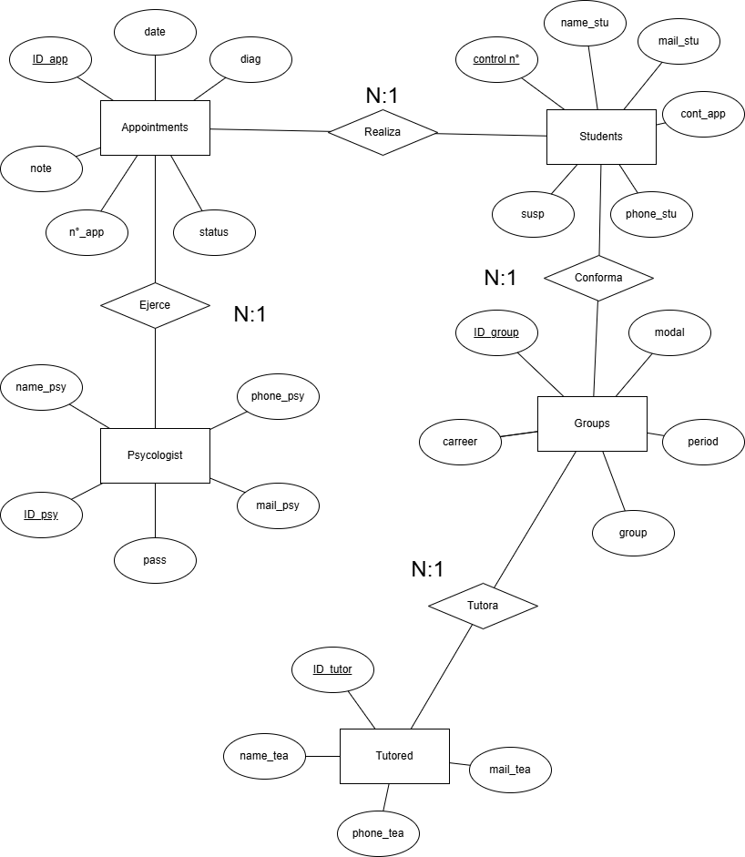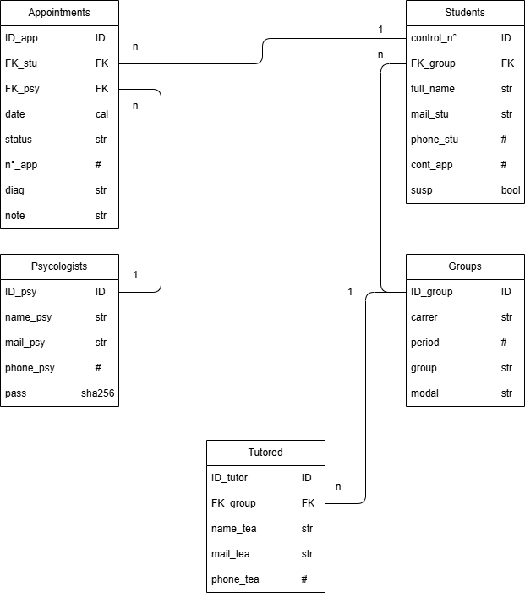
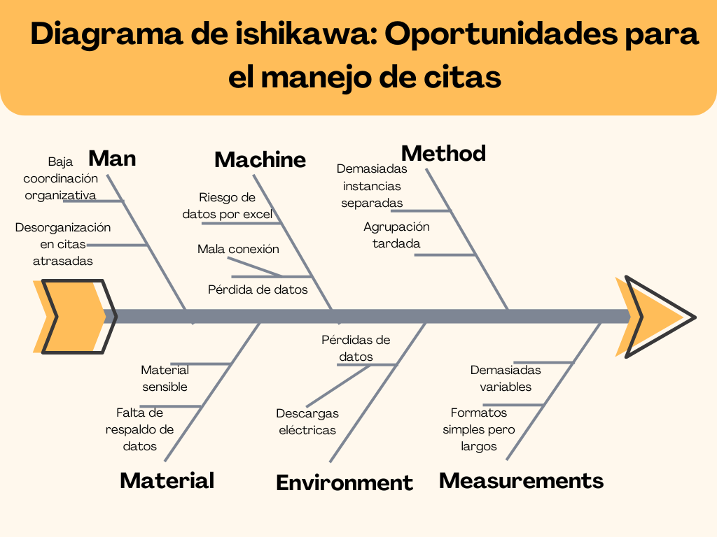
Cuadro PNI
Positivo | Negativo | Interesante
- El proyecto puede resultar beneficioso en el manejo de tareas múltiples.  - La rapidez del programa puede simbolizar en mayor alcance de ayuda sin aumentar ningún otro aspecto.  - Centralización de un proceso por un programa suele ser más productivo.  - El programa sencillo puede llevar a adaptaciones más importantes en el futuro. | - El programa puede resultar difícil de manejar al inicio.  - Si el internet no coopera, el programa puede ser restringido a citas locales.  - Si no se sigue una política de seguridad adecuada, datos sensibles pueden ser obtenidos. | - Al ser un programa simple, puede reinventarse en otros proyectos.  - Casi ningún otro departamento de psicología posee este proyecto.  - Este programa es solamente usado por los miembros del departamento.

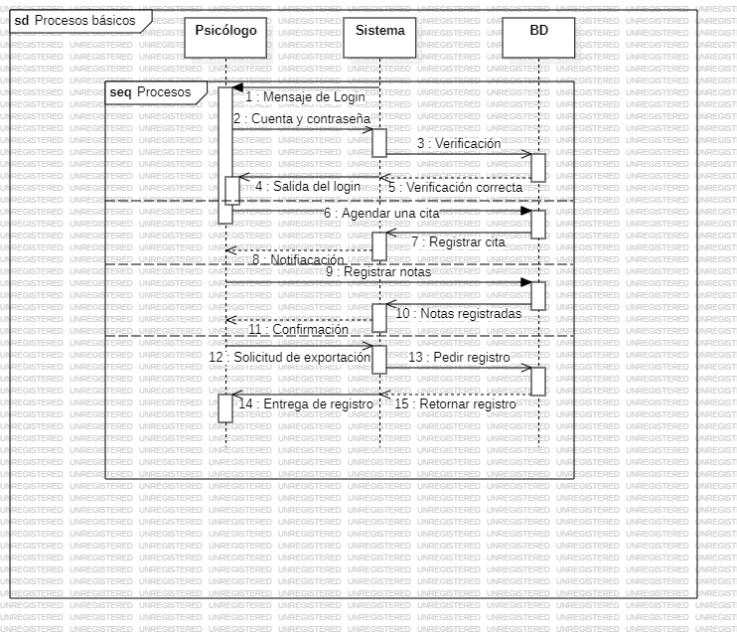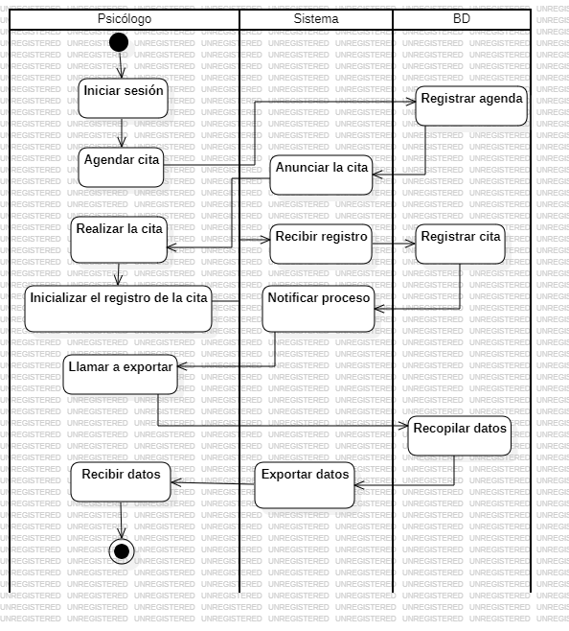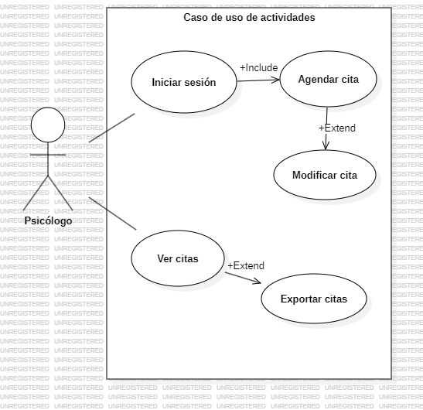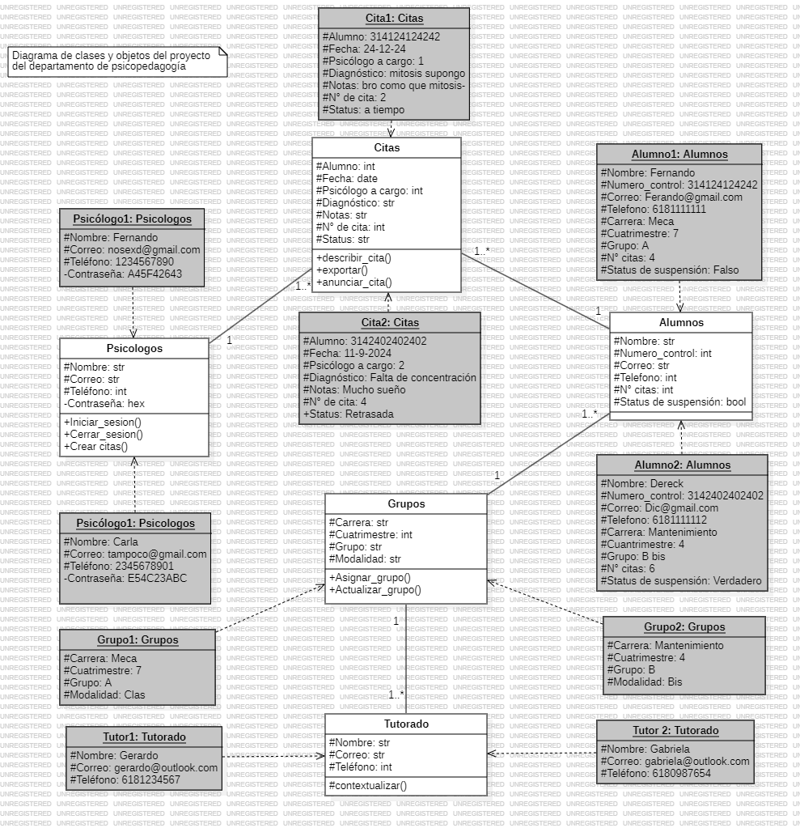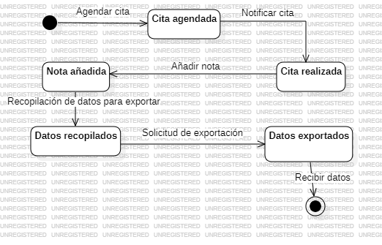
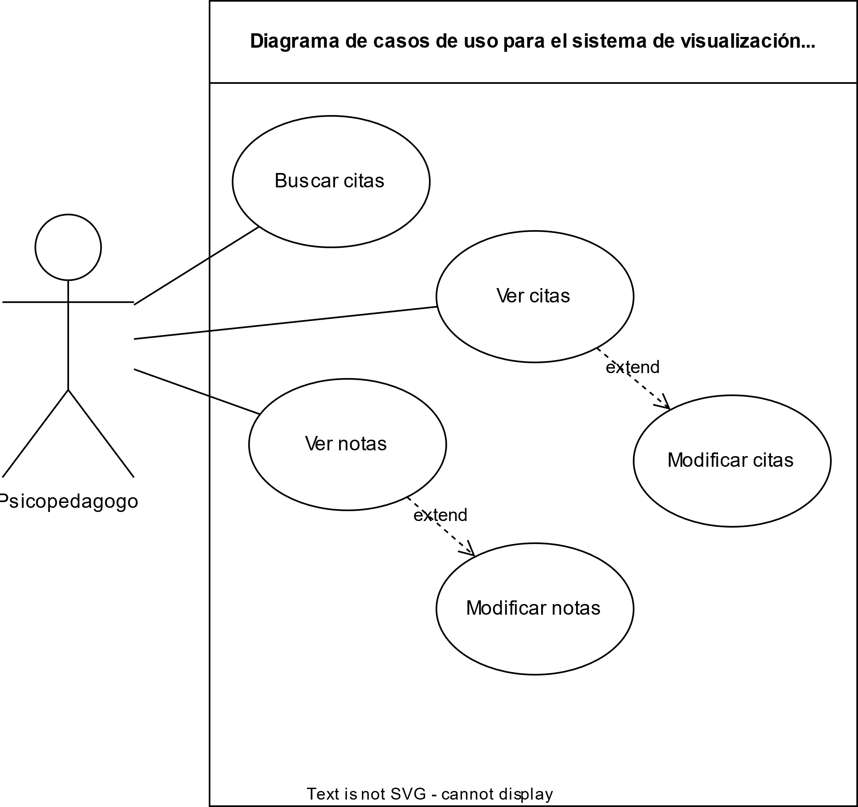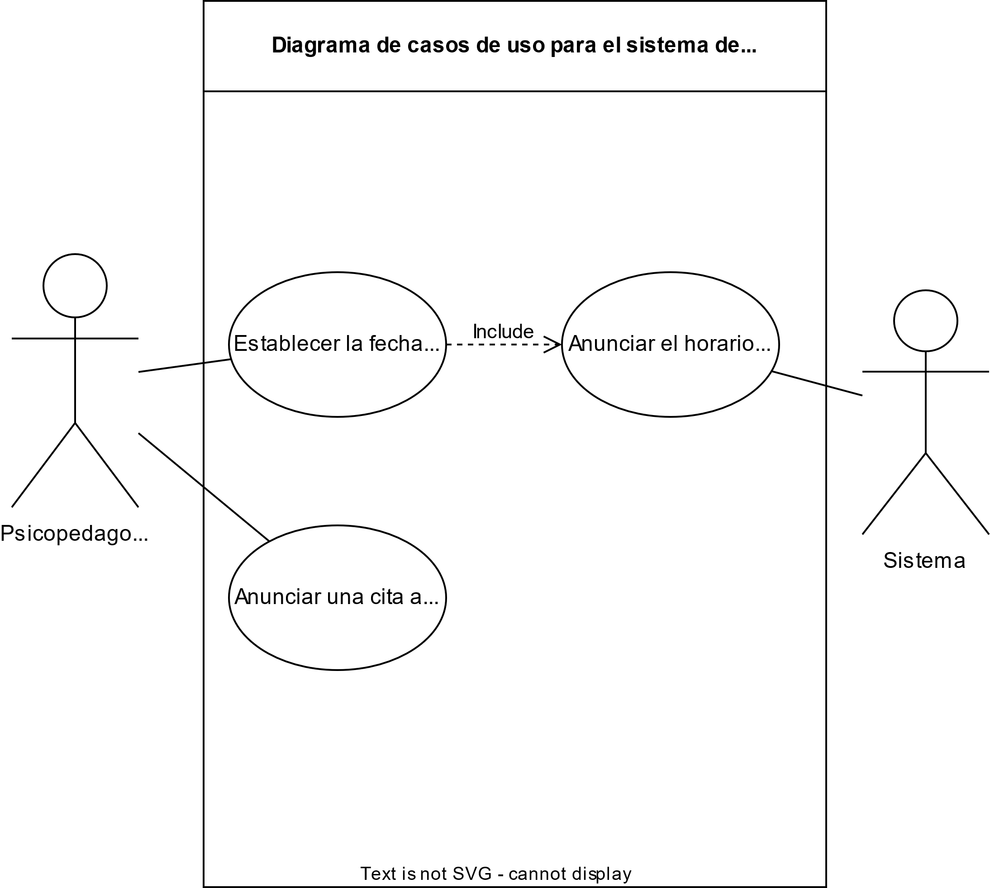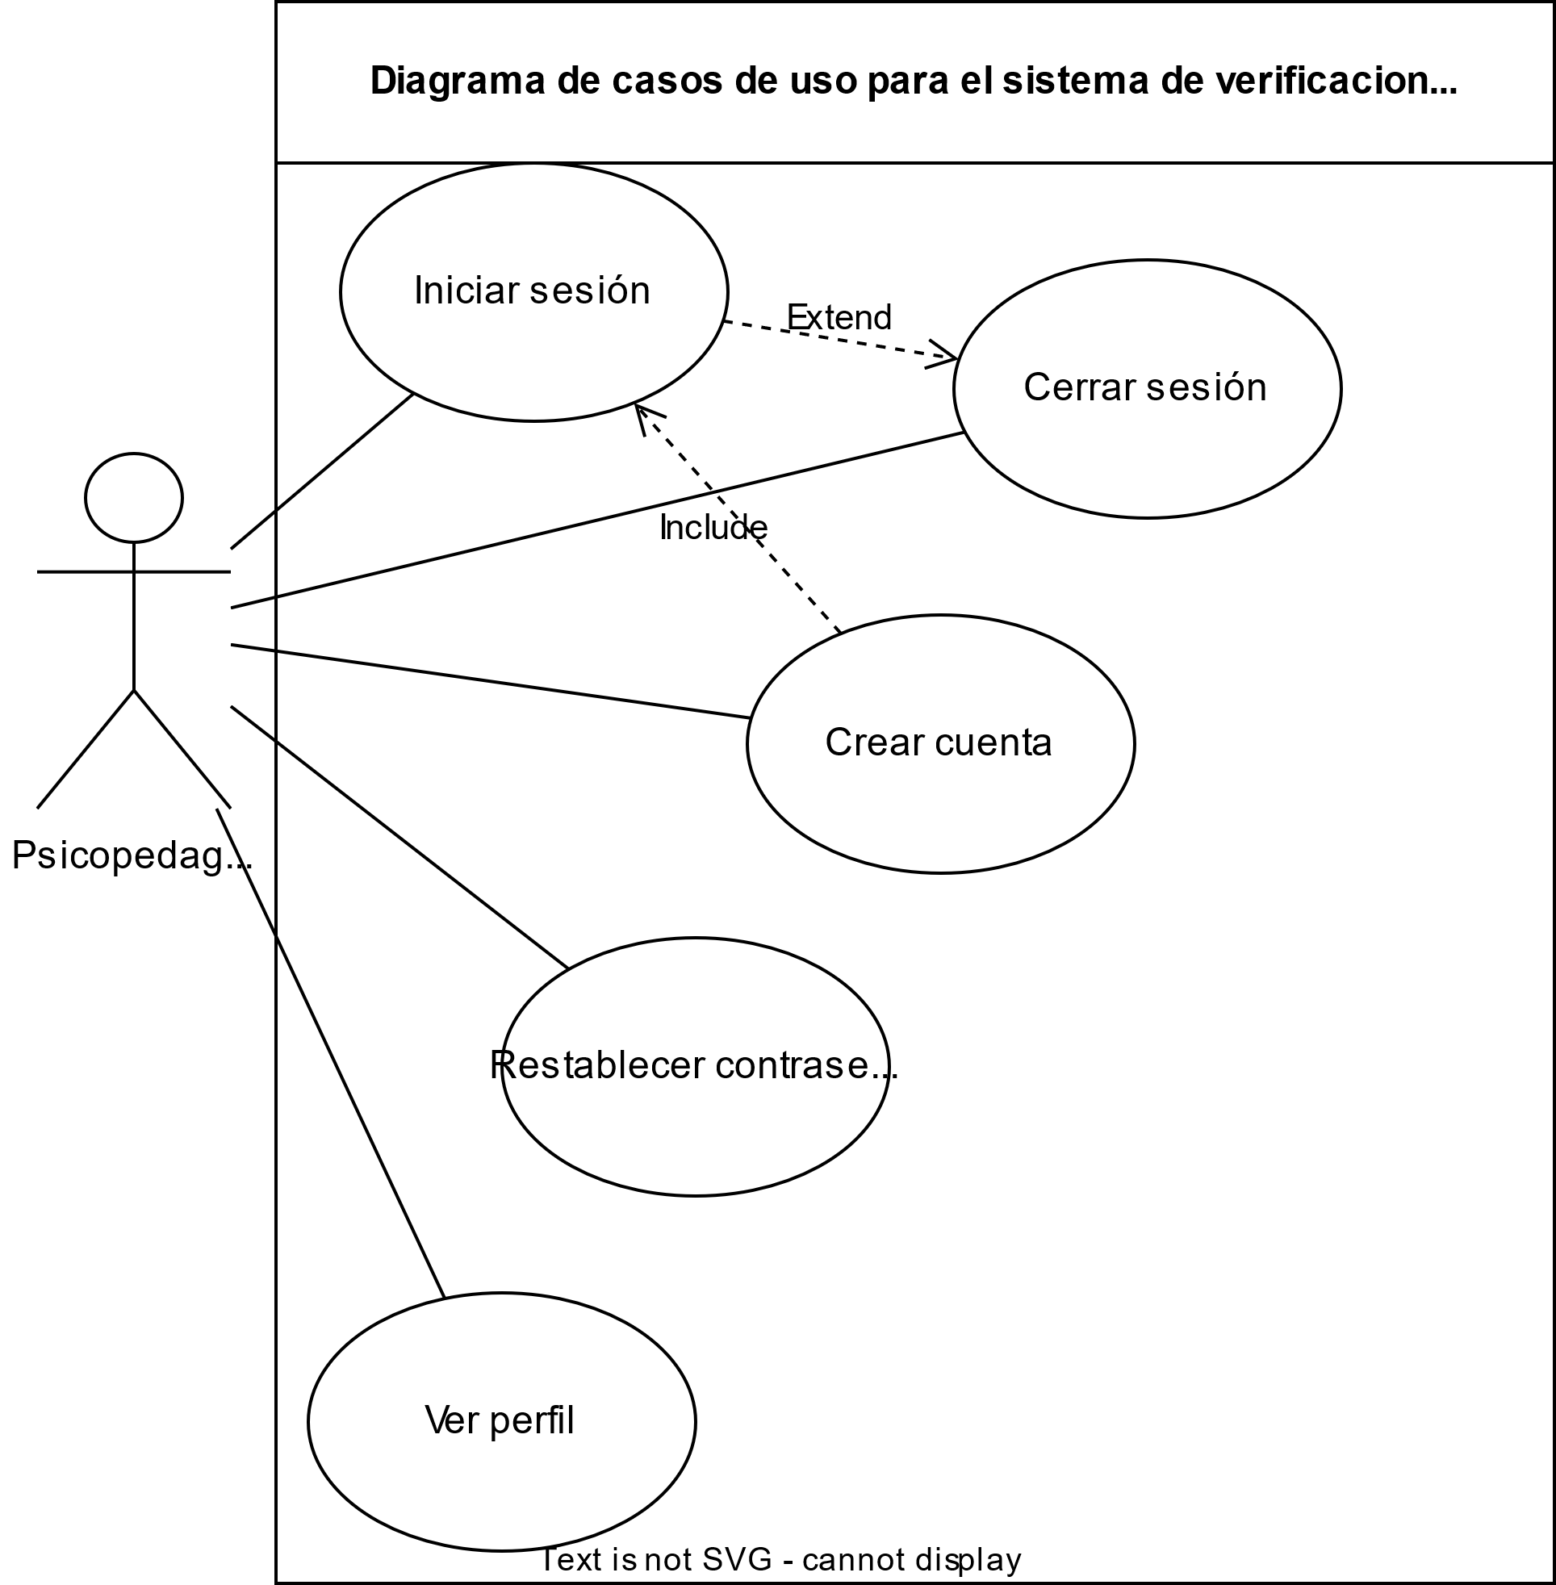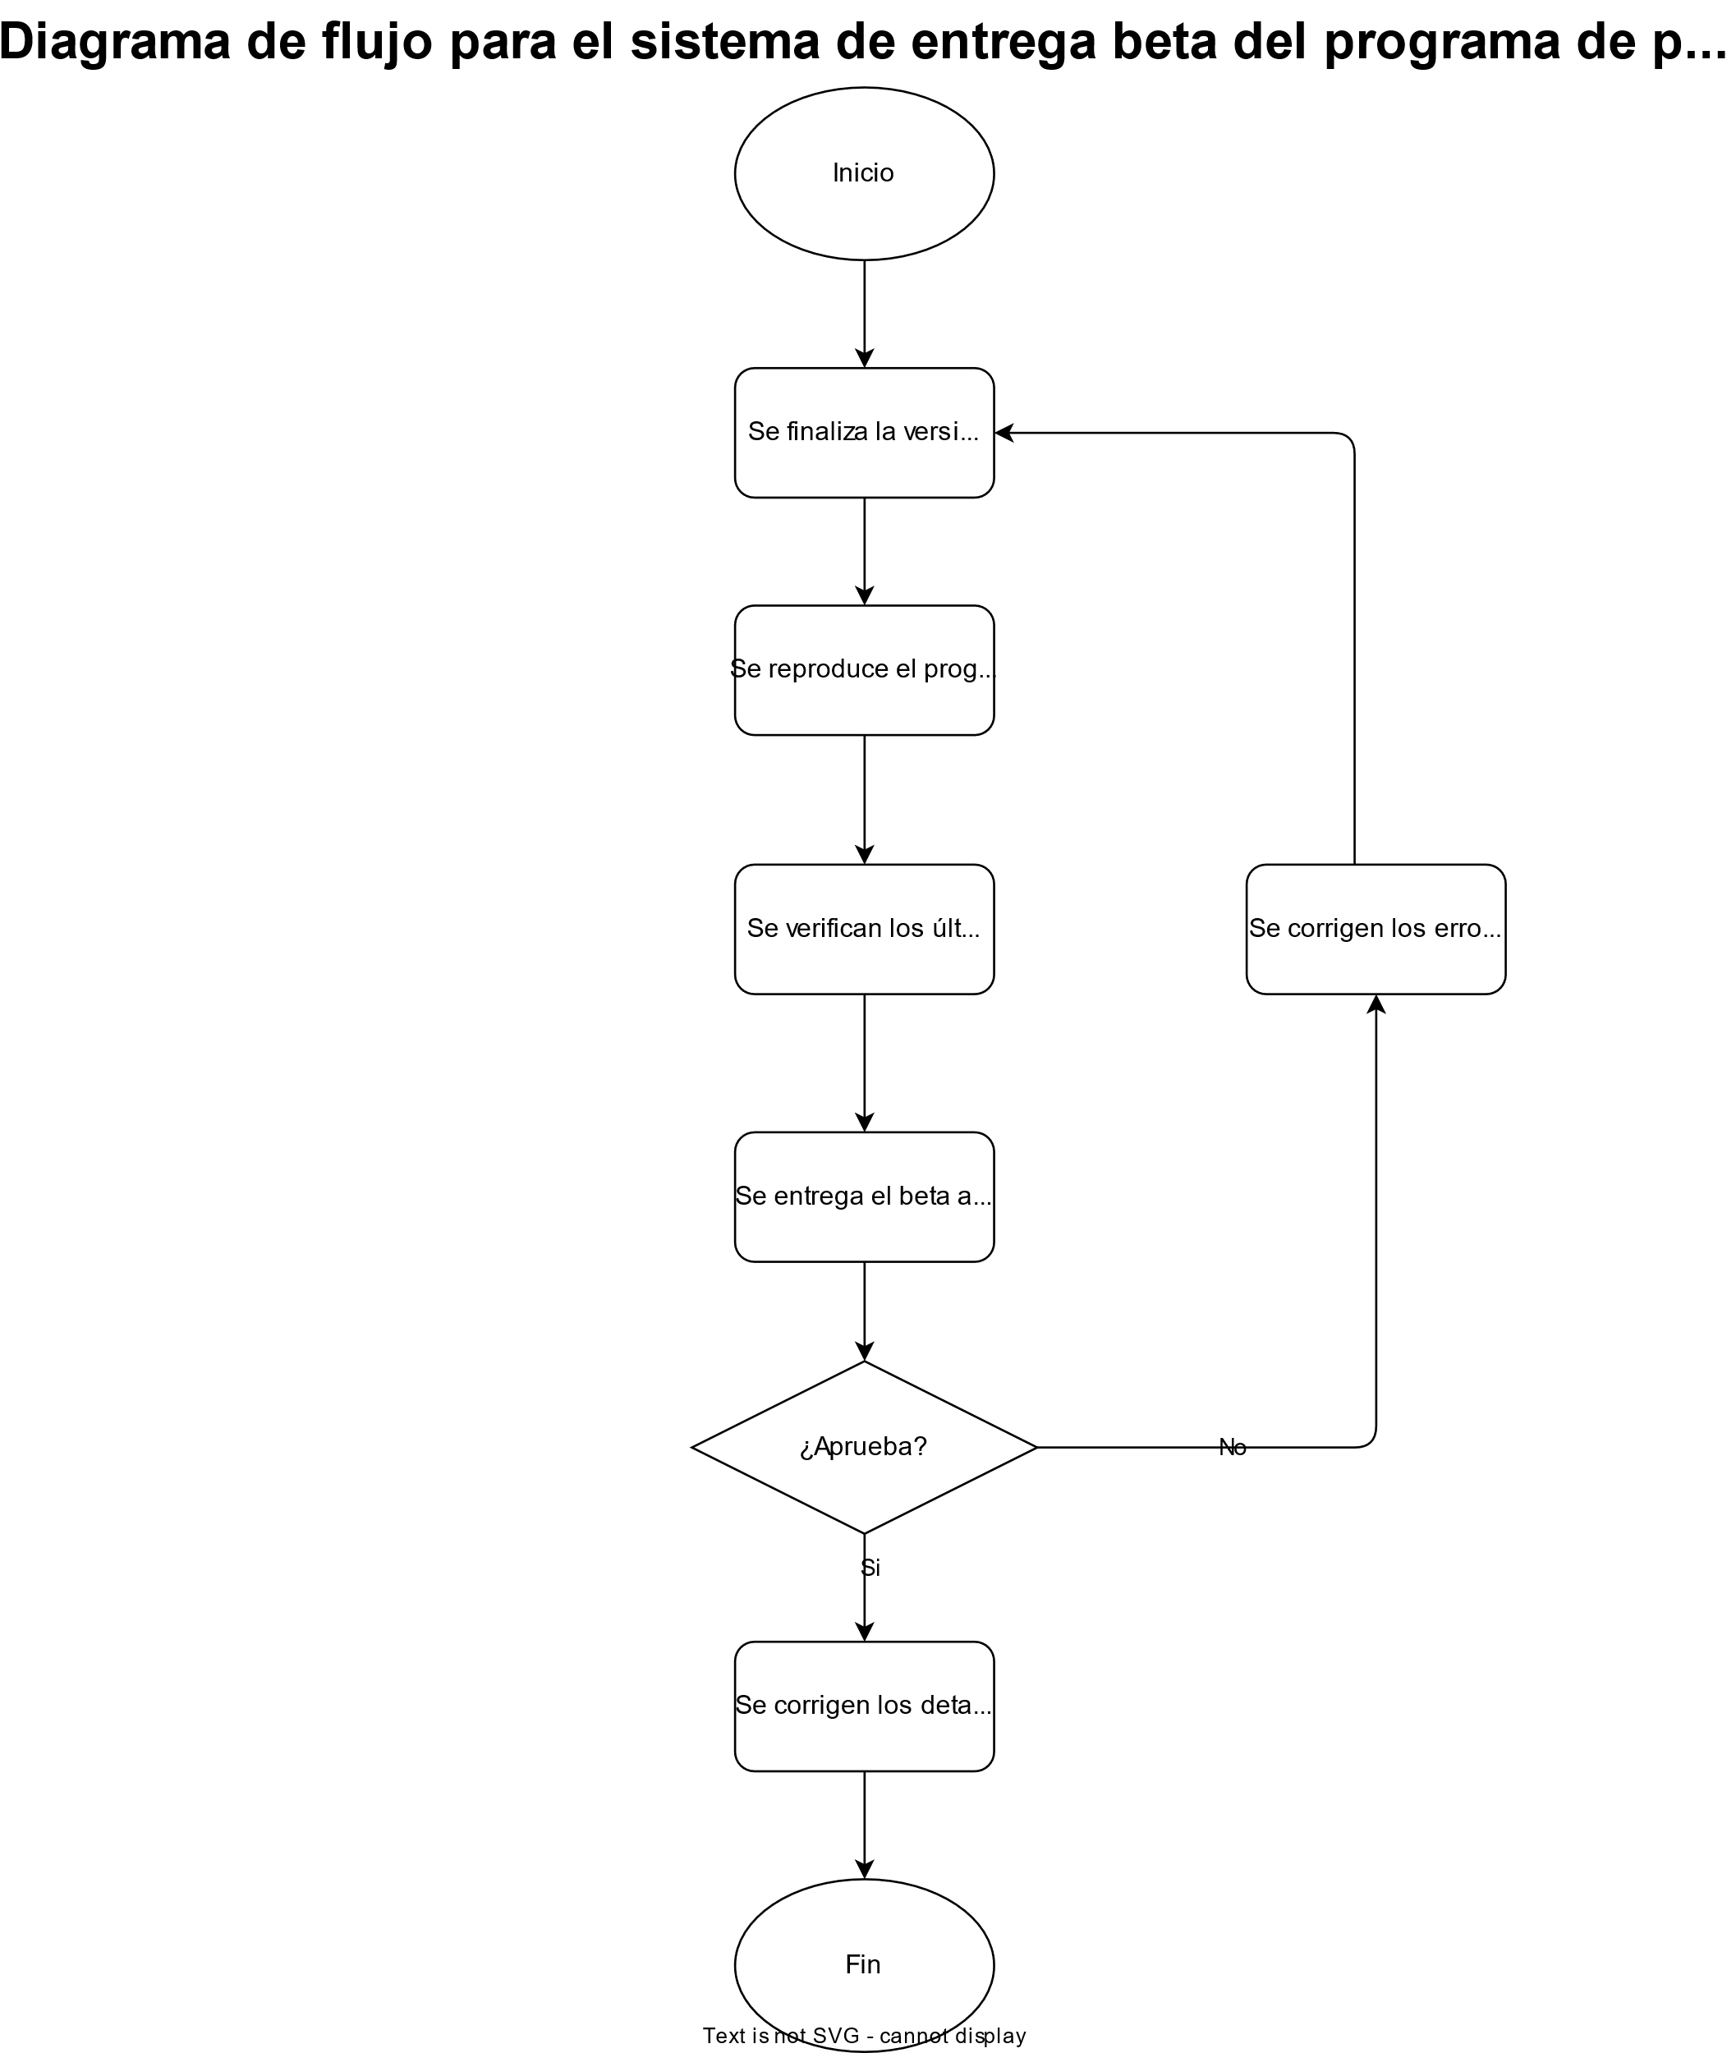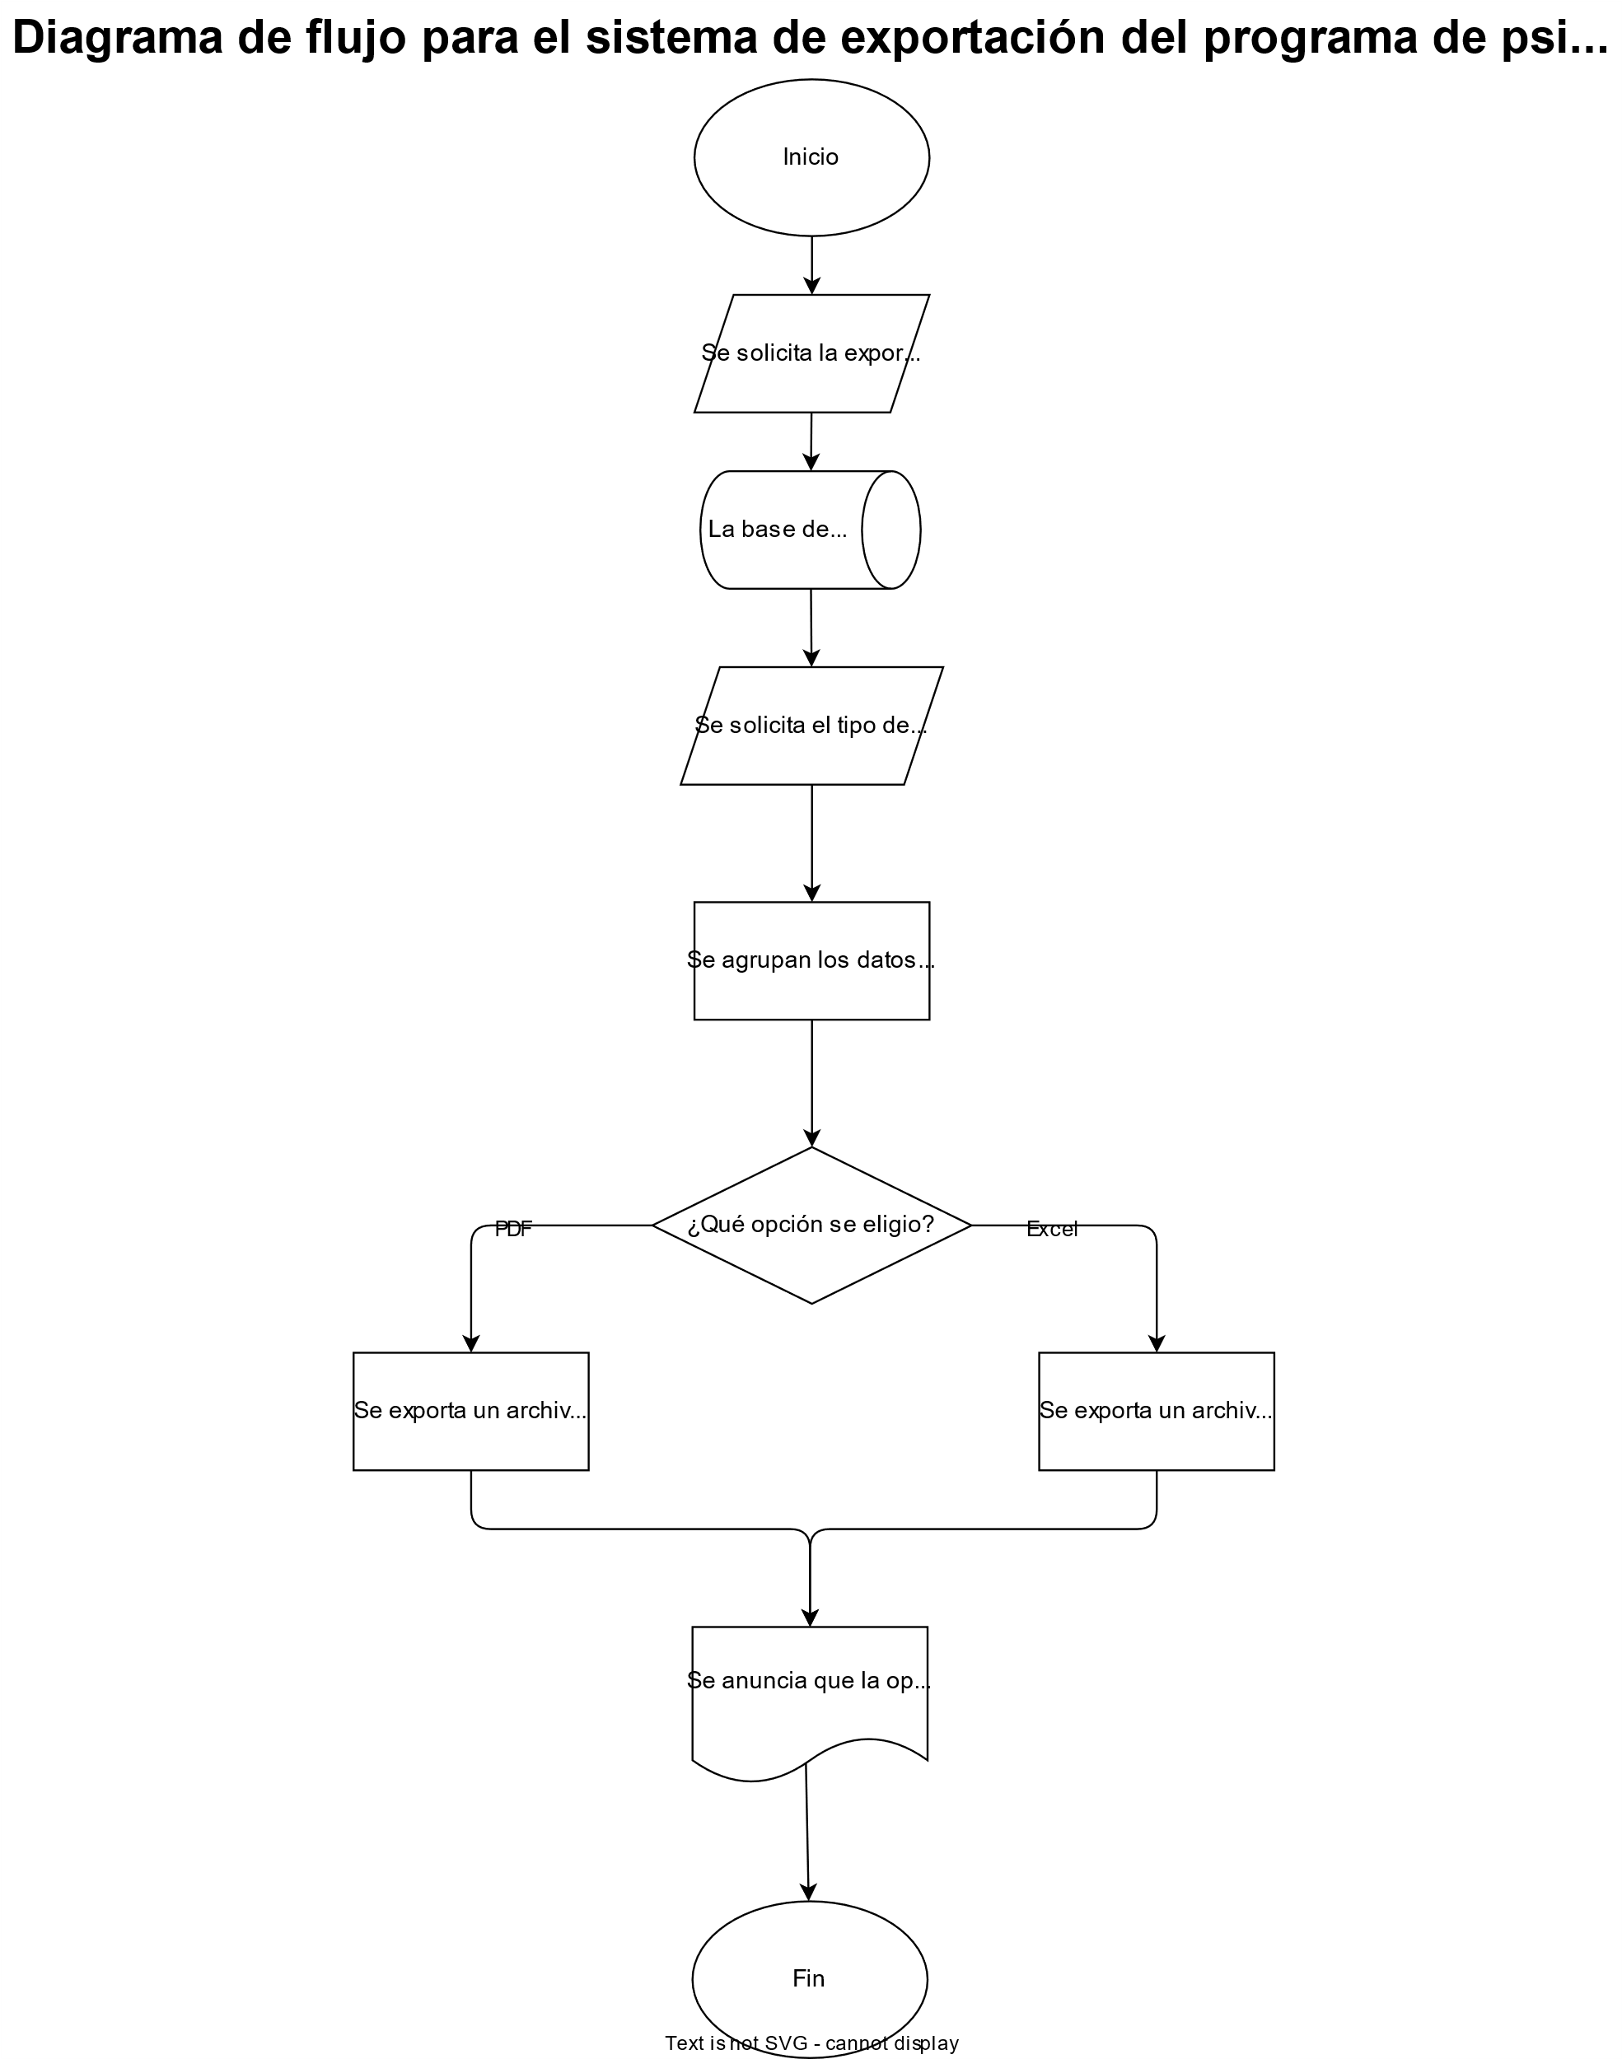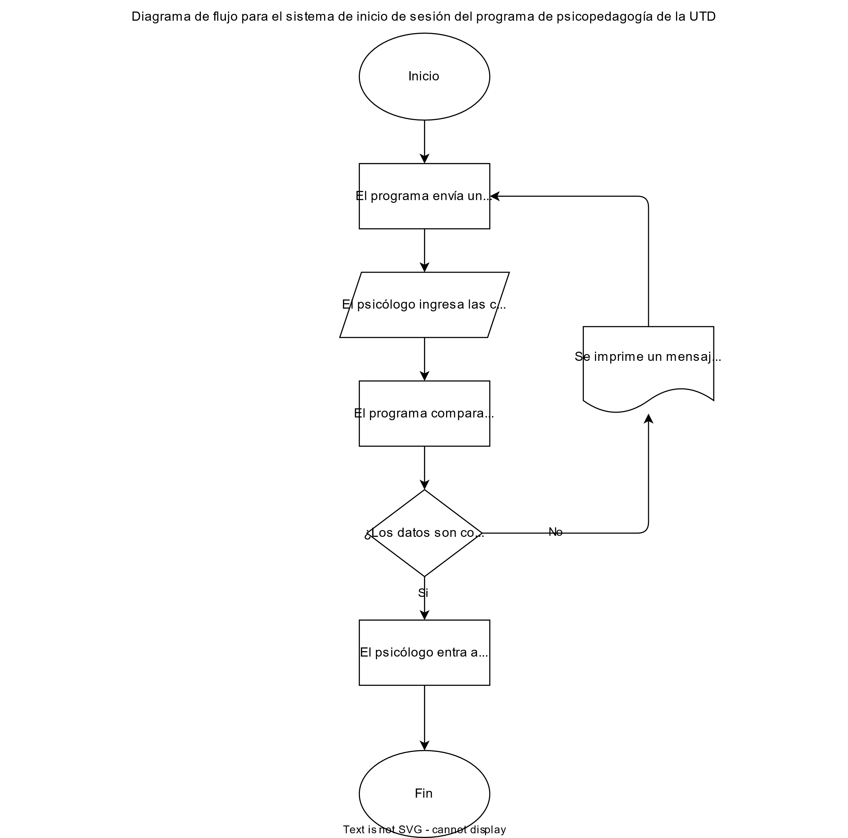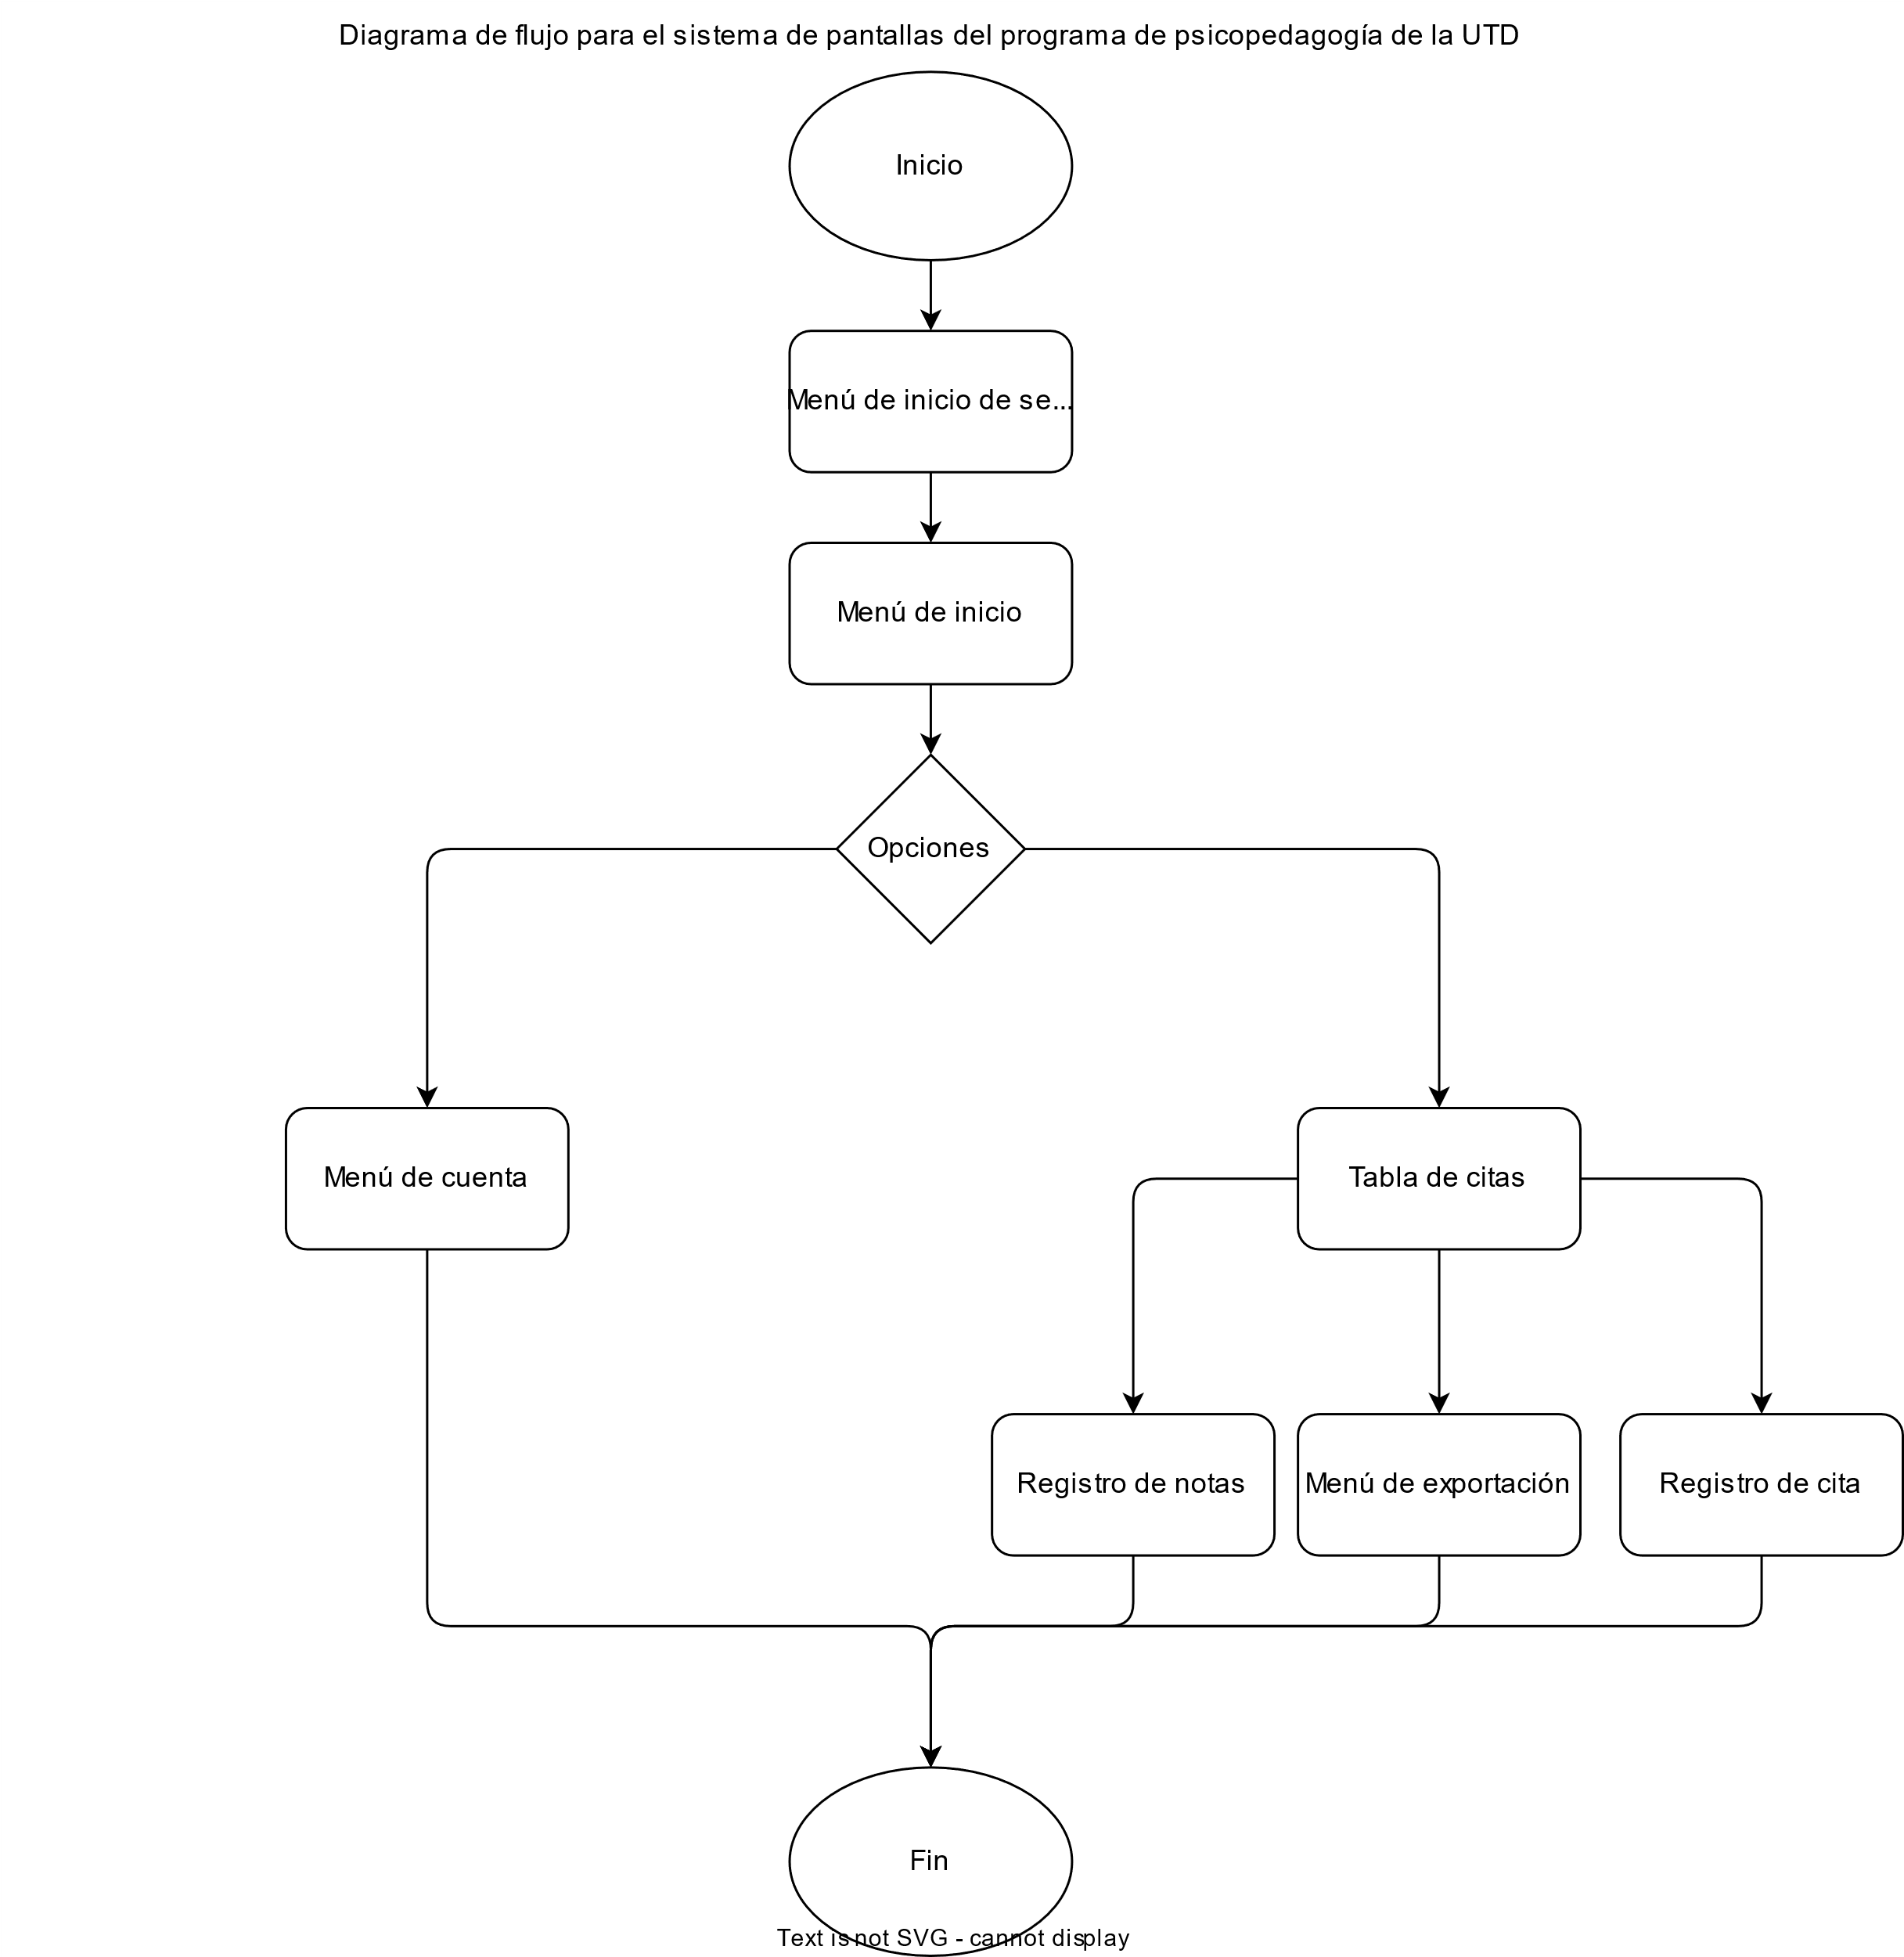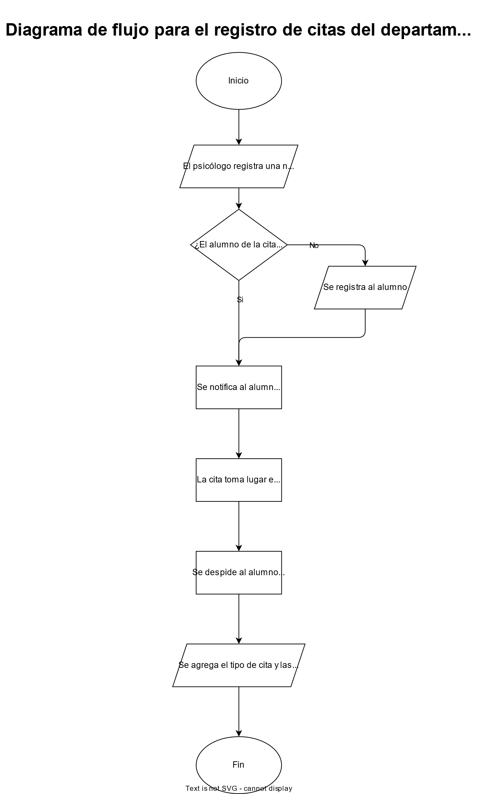

Design artifacts
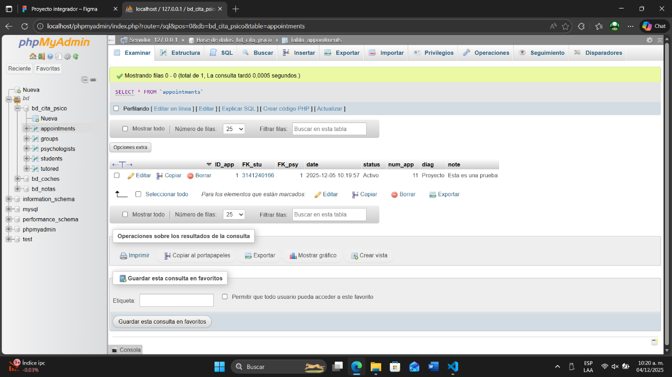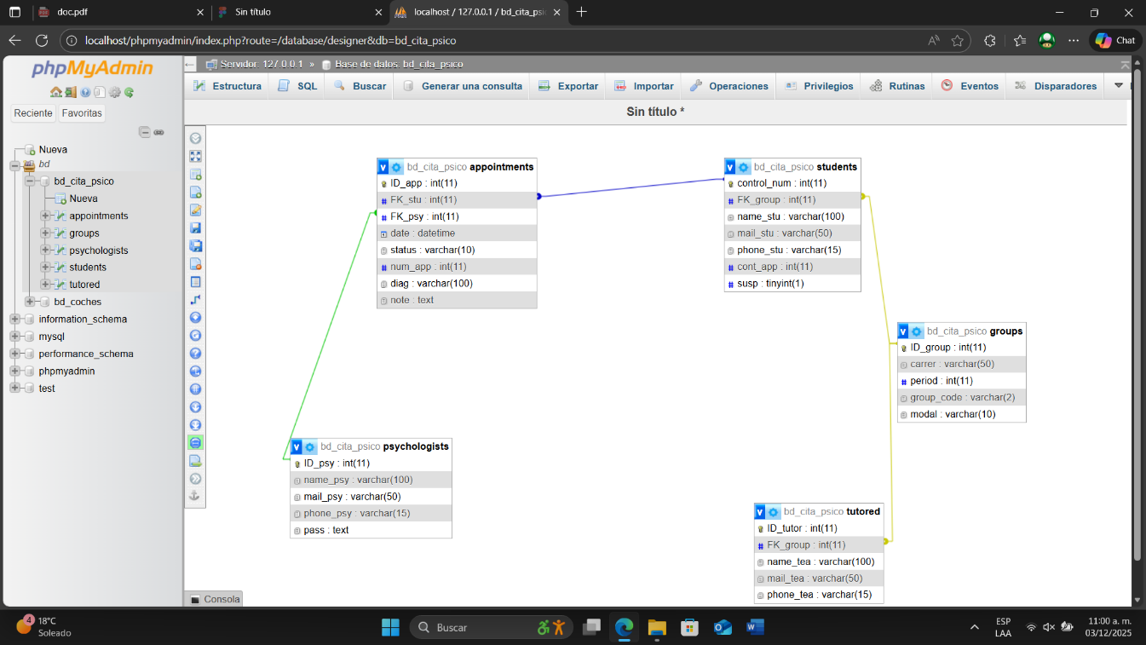

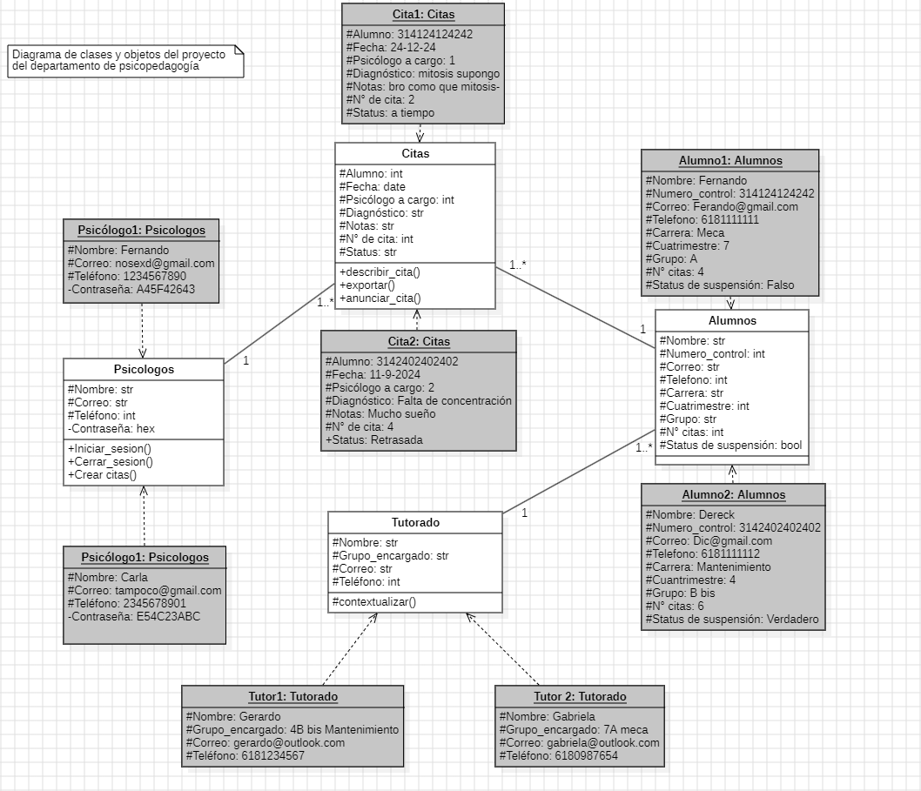
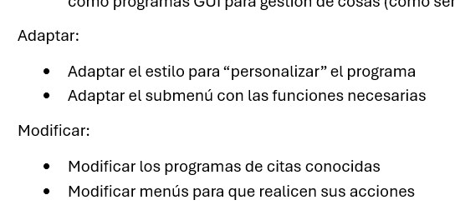
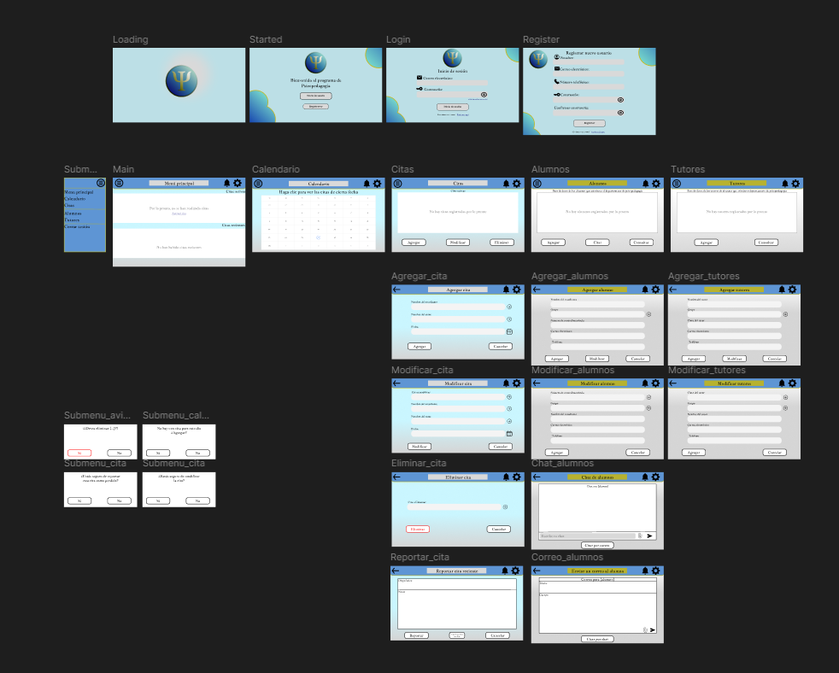

Process evidence
